|  |
| --- |
| Book Sale Portal: Project Documentation  Mark Joseph C. Nagrampa  Web Systems & Technologies |
|  |

# Introduction

The project being proposed is an online buy-and-sell platform for books named: *Book Sale Portal*. As the description implies, the intended users of this platform are book retailers (sellers) and purchasers (buyers). A single moderator (administrator) will regulate the actions performed in this platform.

The system is particularly catered towards small-to-medium-sized retail companies with established store locations; although, individual sellers can also use the platform’s features provided that they undergo the platform’s verification process. Through the use of this platform, sellers will be able to take advantage of increased product visibility and customer interaction through community thread postings and basic messaging services.

The platform expects strict compliance from users regarding its terms of service agreement. It is the administrator’s responsibility to ensure that these conditions are being followed. These responsibilities include: verifying seller accounts, closing accounts due to violations, and keeping users informed through platform announcements. The necessary tools for these functions are provided by the platform therewith.

# Data

The website will store various information regarding users, products, and reported complaints. These information are outlined as follows:

1. **Users**
   1. **Buyers**

Name – The buyer’s name will be used to identify a buyer in thread comment interactions and private messages.

Email – The buyer’s email will be used as a login credential for his/her account.

Contact No – The buyer can provide his/her contact no. for easier communication with sellers during transactions coordinated in messages.

Image – The buyer can include a profile picture which can be used to identify him/her easier in thread comment interactions and messages.

* 1. **Sellers**

Company Name – The seller’s name will be used to identify it in item postings, thread comment interaction, and private messages.

Company Email - The seller’s email will be used as a login credential for its account.

Company Contact No & Address, Contact Person Name & Contact Details – This information must be provided in order to verify the credibility of the company during the registration process.

Image – The seller can include a company logo picture which can be used to identify it easier in item postings, thread comment interactions, and messages.

* 1. **Admin**

Name – The admin’s name will be used to identify the admin in posted announcement messages.

Email - The admin’s email will be used as a login credential for his/her account.

Image - The admin can include a profile picture which can be used to identify the admin in posted announcement messages.

1. **Products**

Book Title, Author, Genre, Price, Binding Type, and Image – This product information will be used to advertise posted items to potential buyers.

1. **Reported Complaints**

Screenshot / Image Proof of Violation – The system requires an image proof of a TOS violation to help the admin verify the credibility of a reported complaint.

# Platform functionality

Home Page - 1

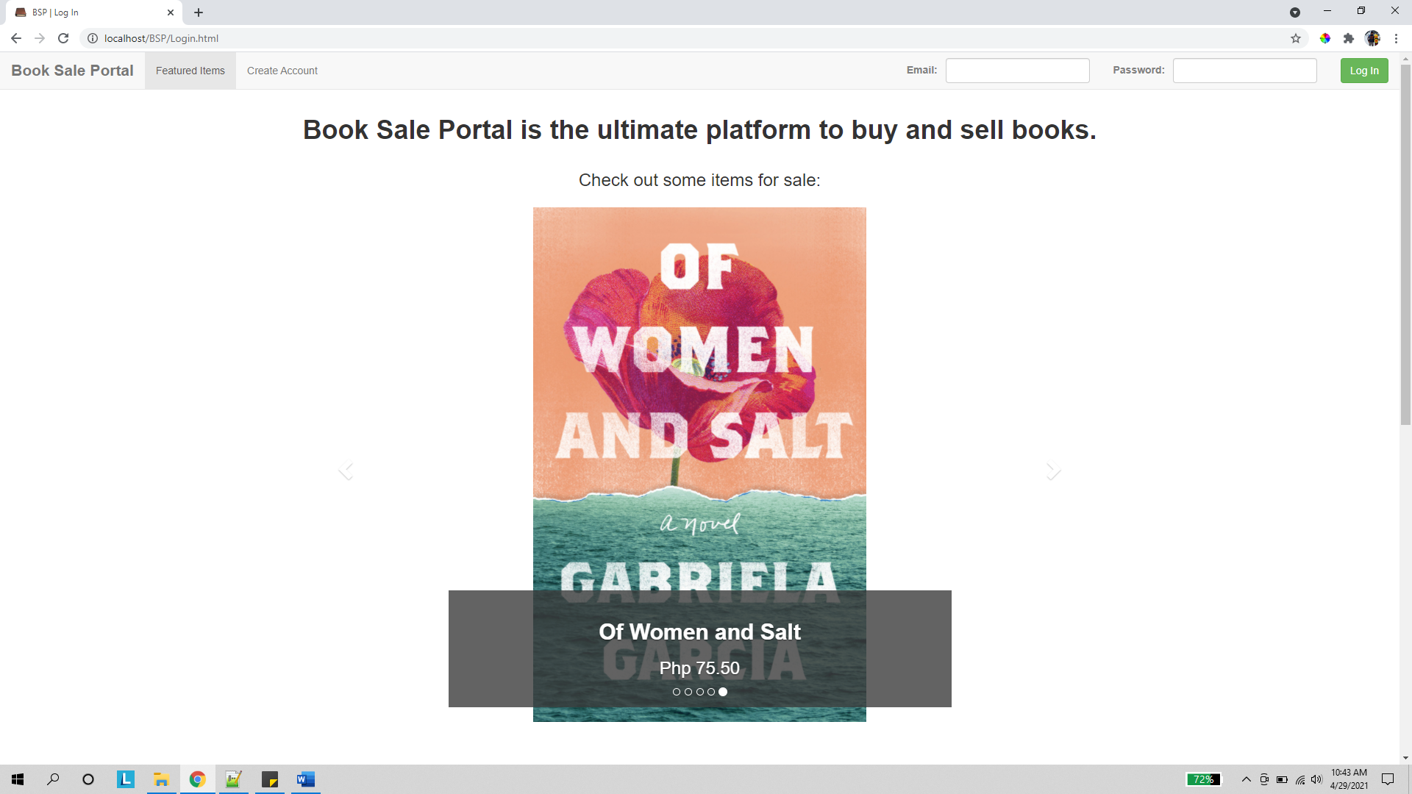

In the home page, site visitors can view an arbitrary list of items being sold. A carousel control highlights a random list of up to 5 items currently being sold in the platform. Aside from this, users can also log in to the website via the form control seen in the page header.

Home Page – 2

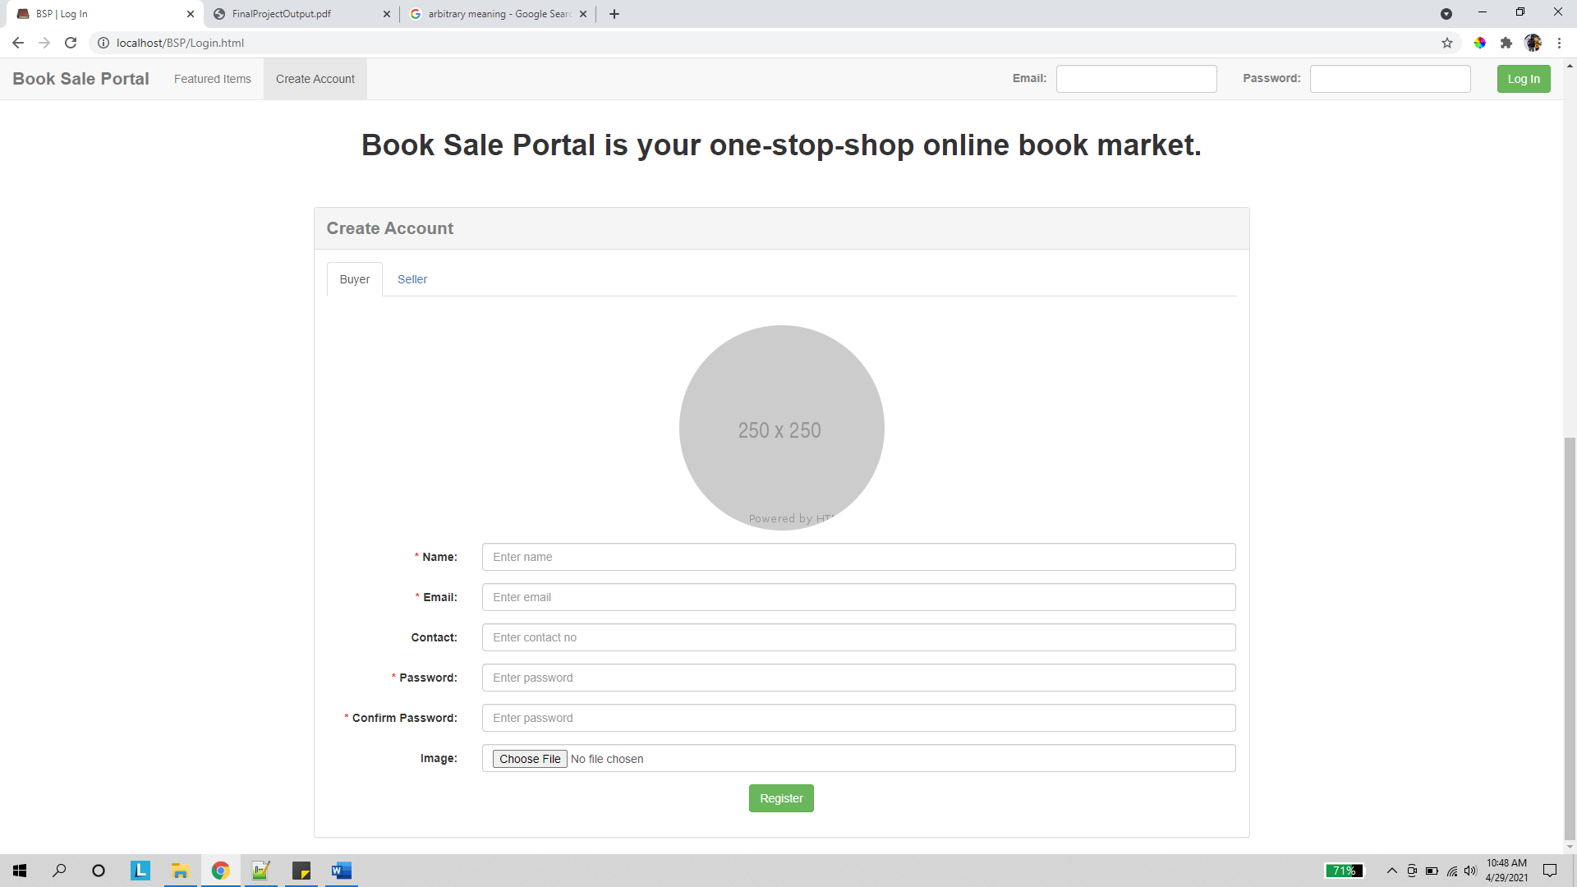

Scrolling down the home page, site visitors can register via the form seen above.

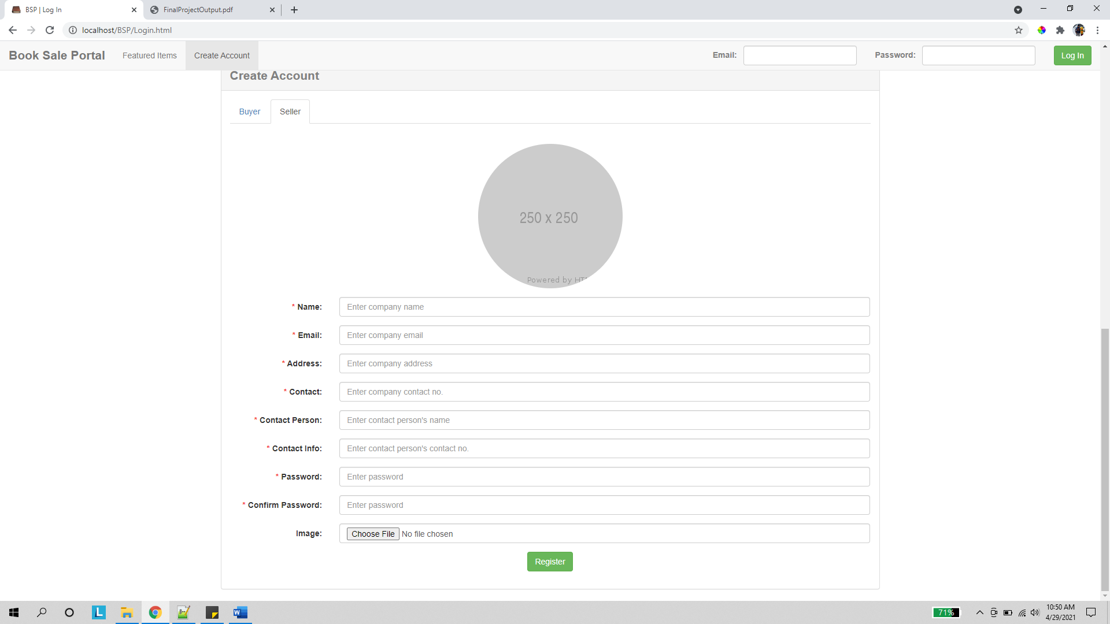

The visitor can select the appropriate account type for registration via the tab control.

1. **Admin Pages**

Profile

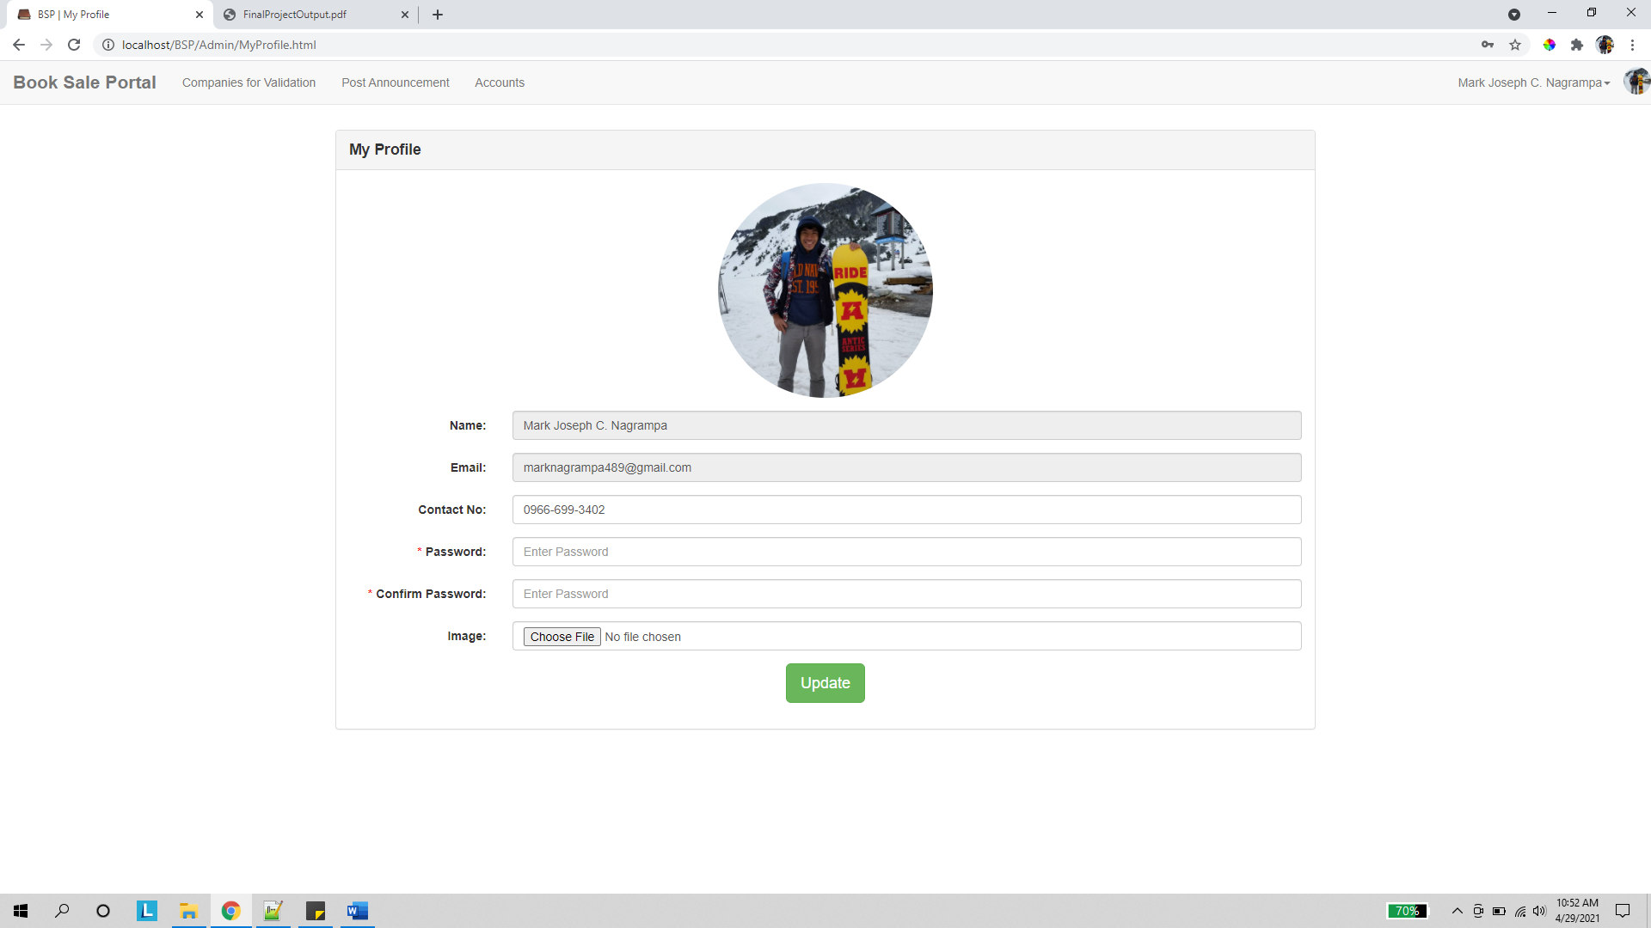

Once logged in, the admin is redirected to his profile page. Here, he can choose to edit the account info he provided.

Companies for Validation

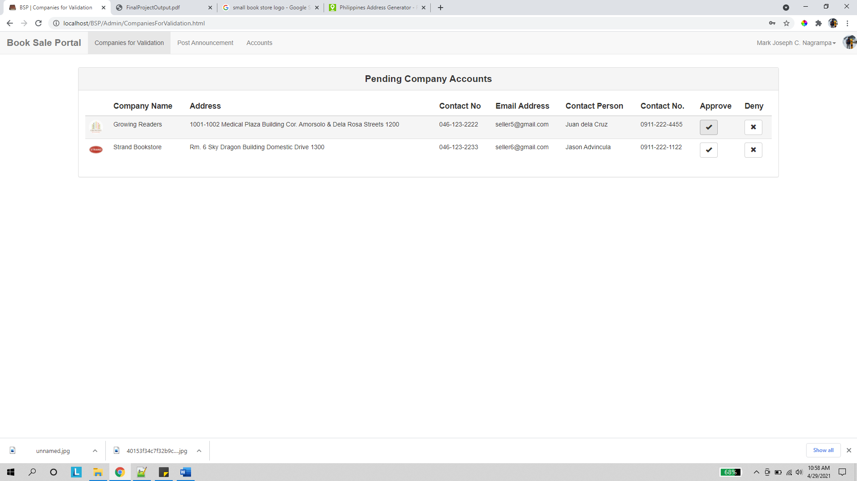

The admin can view a list of pending companies for approval via this page. Here, he can choose to approve or deny a company after performing due diligence.

Post Announcement

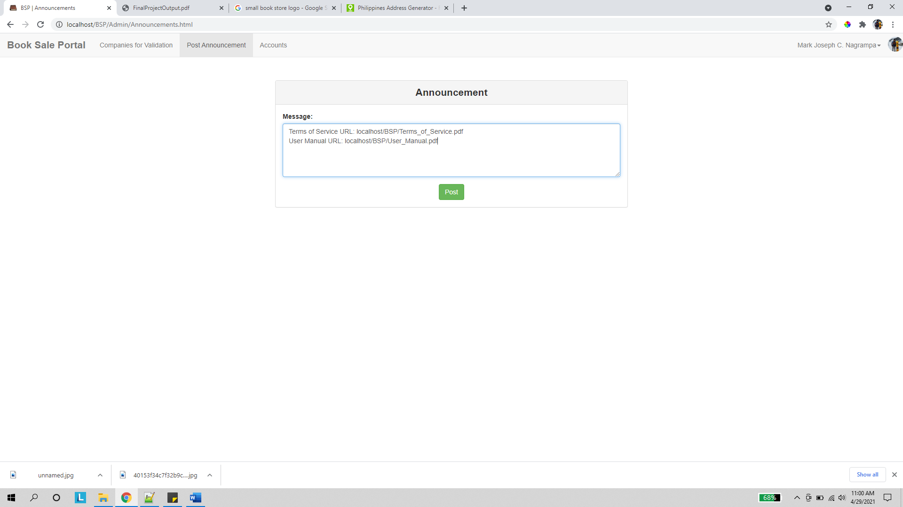

The admin can post an announcement message via this page. This message will be broadcasted to all seller and buyer accounts and can be used to post important website resources such as terms of service or user manual document links. Only one announcement message will be relayed to other accounts at a time.

Accounts

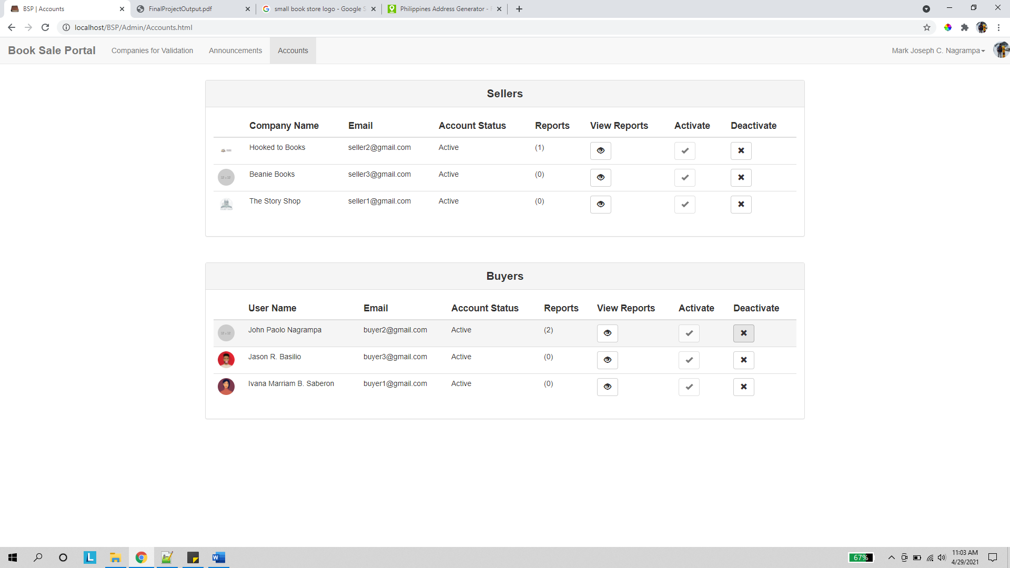

The admin can manage user accounts via this page. Here, he can toggle the activation status of both seller and buyer accounts.

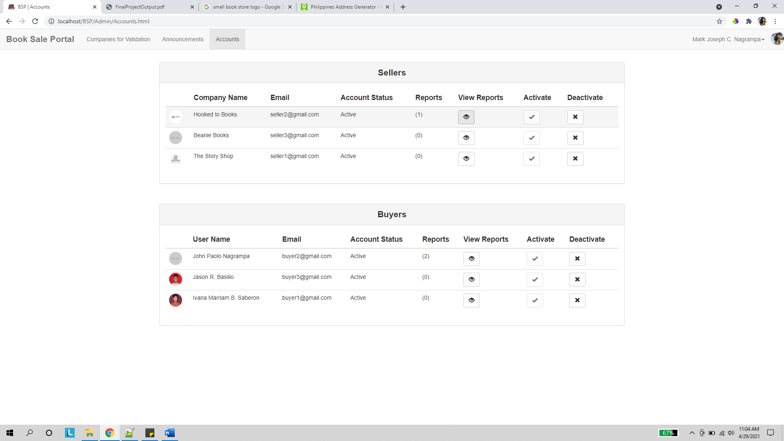

Upon clicking the view reports button on a record, the admin is redirected to the succeeding page.

View Complaint

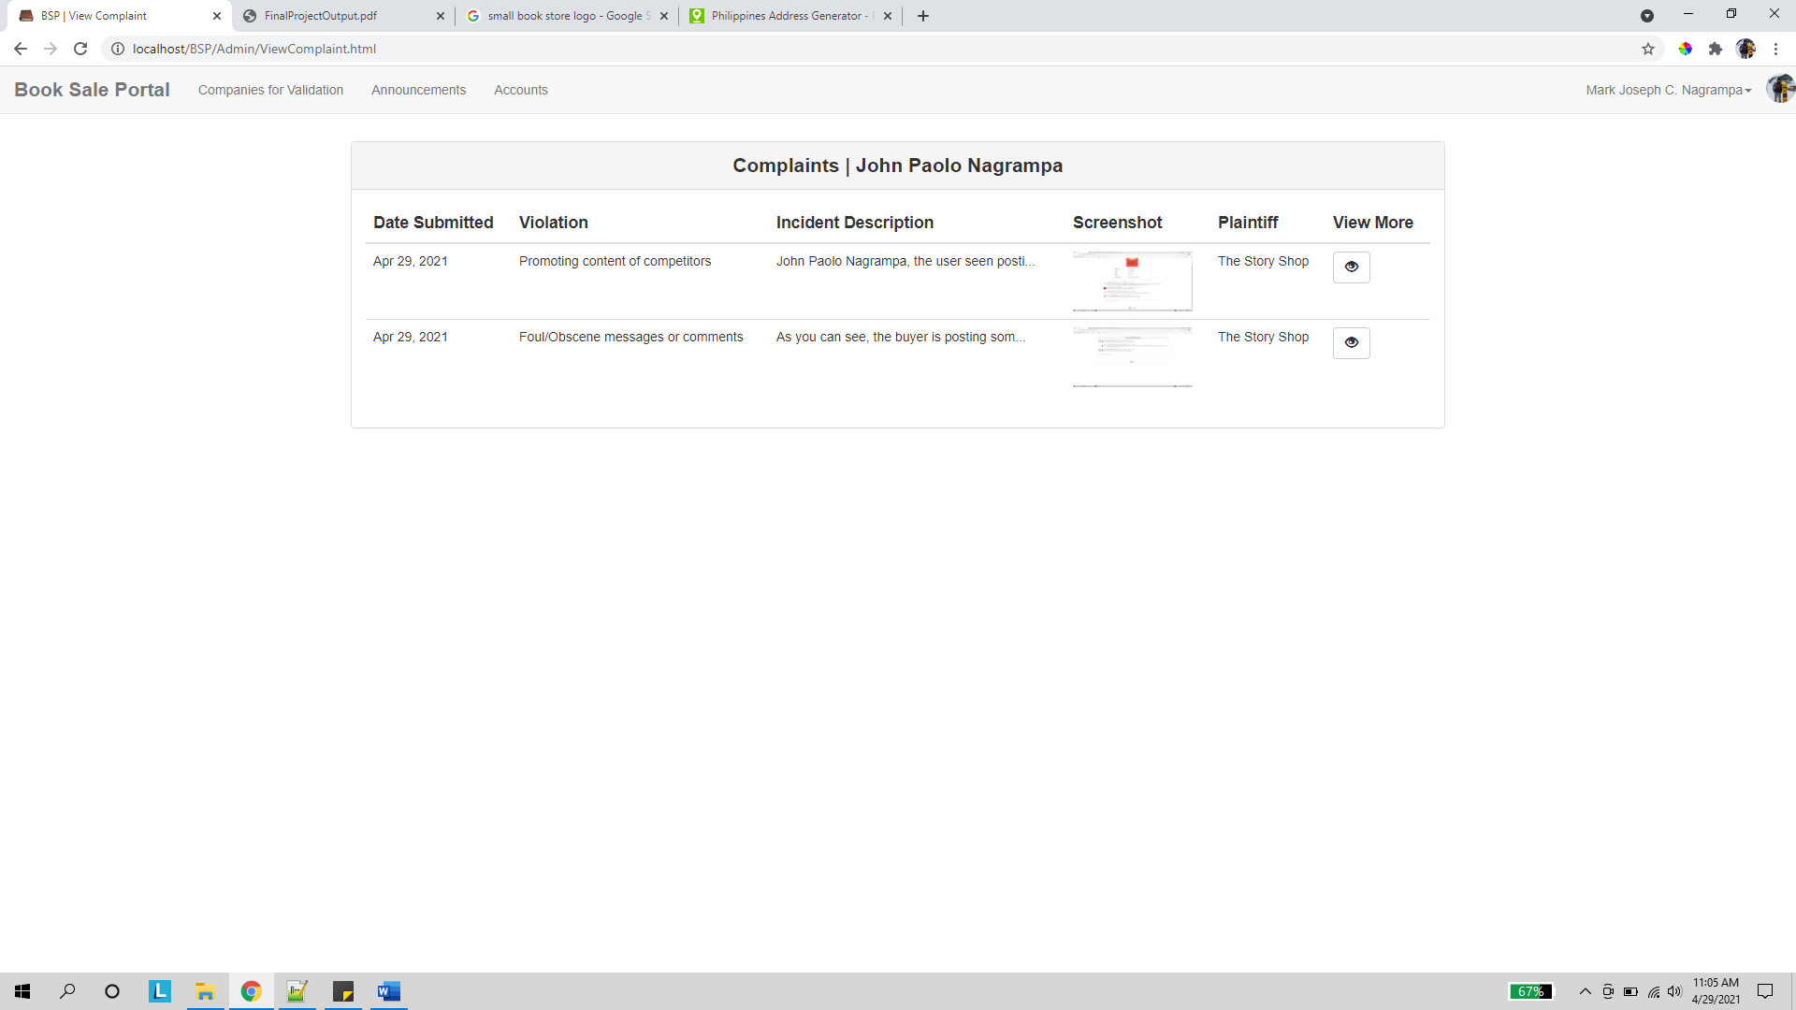

The admin can see an aggregated list of all reported complaints filed against the account selected in the previous page.

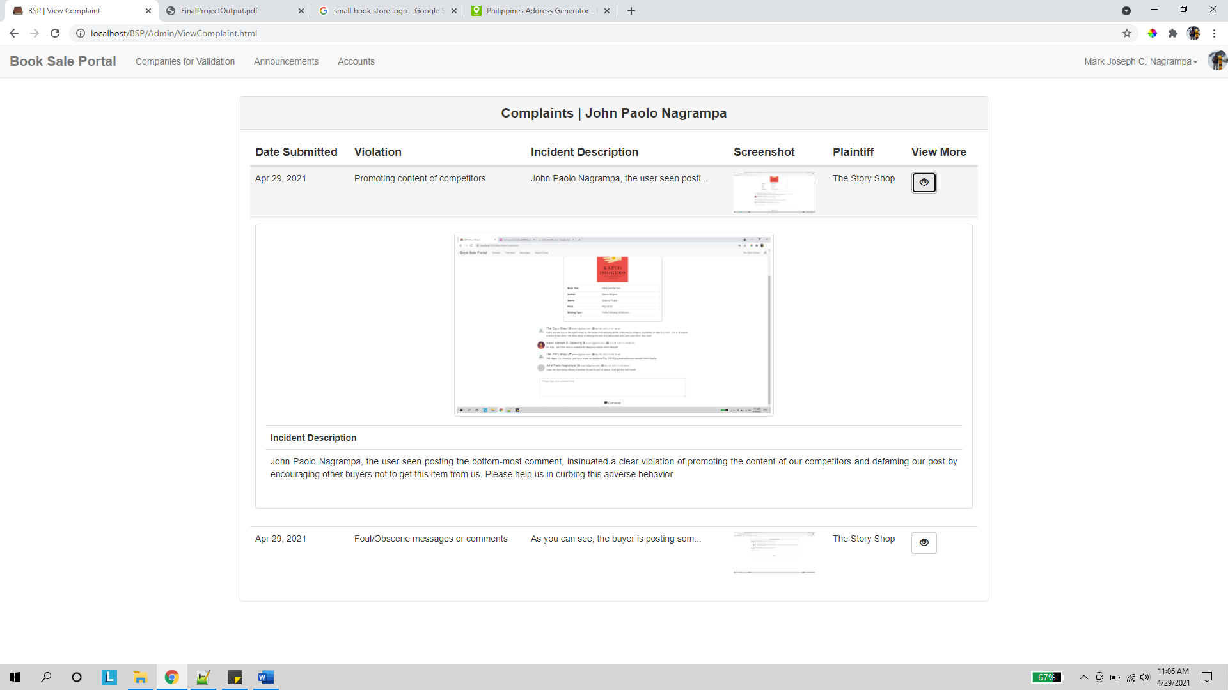

Upon clicking the view more button, a larger display of the screenshot and the complete text of the reported incident will be displayed.

1. **Seller Pages**

Profile

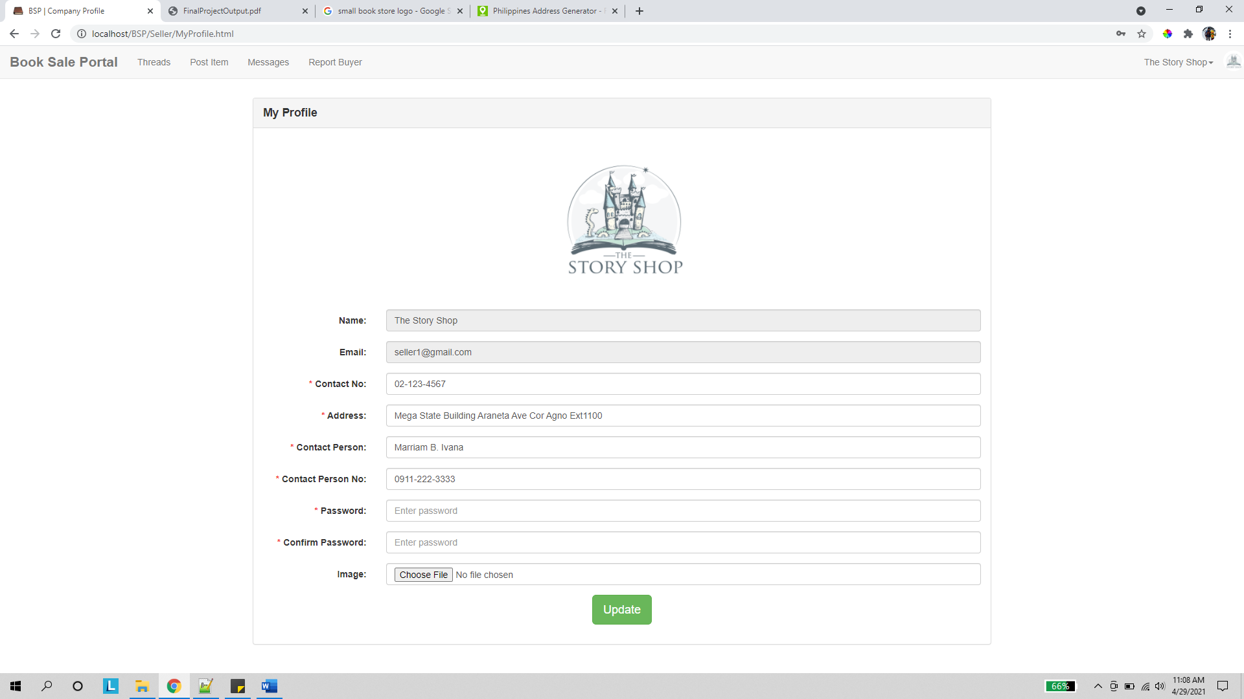

Once logged in, the seller is redirected to its profile page. Like the previous profile page, the seller can modify its account info here.

Threads

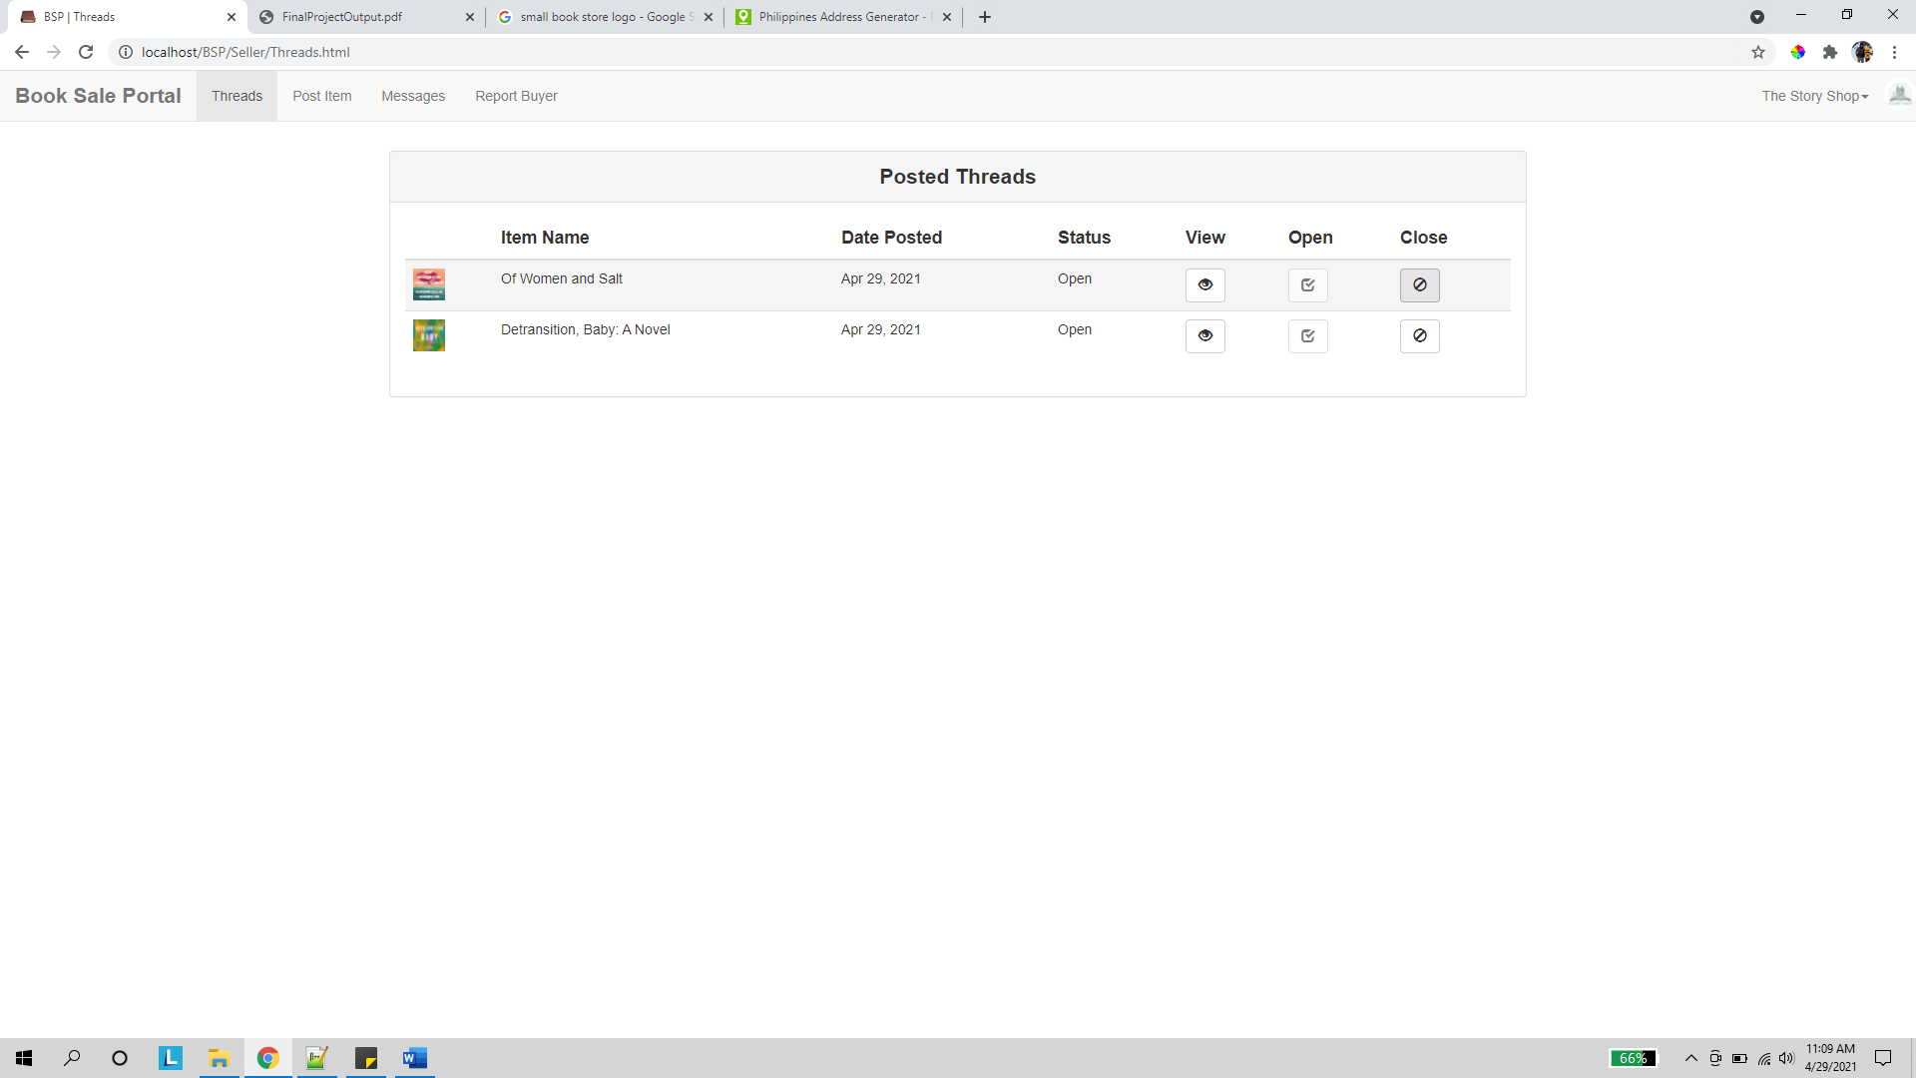

In the threads page, the seller company can view a list of its posted items. Here, it can choose to open or close the discussion thread of a particular item to render that thread uncommentable.

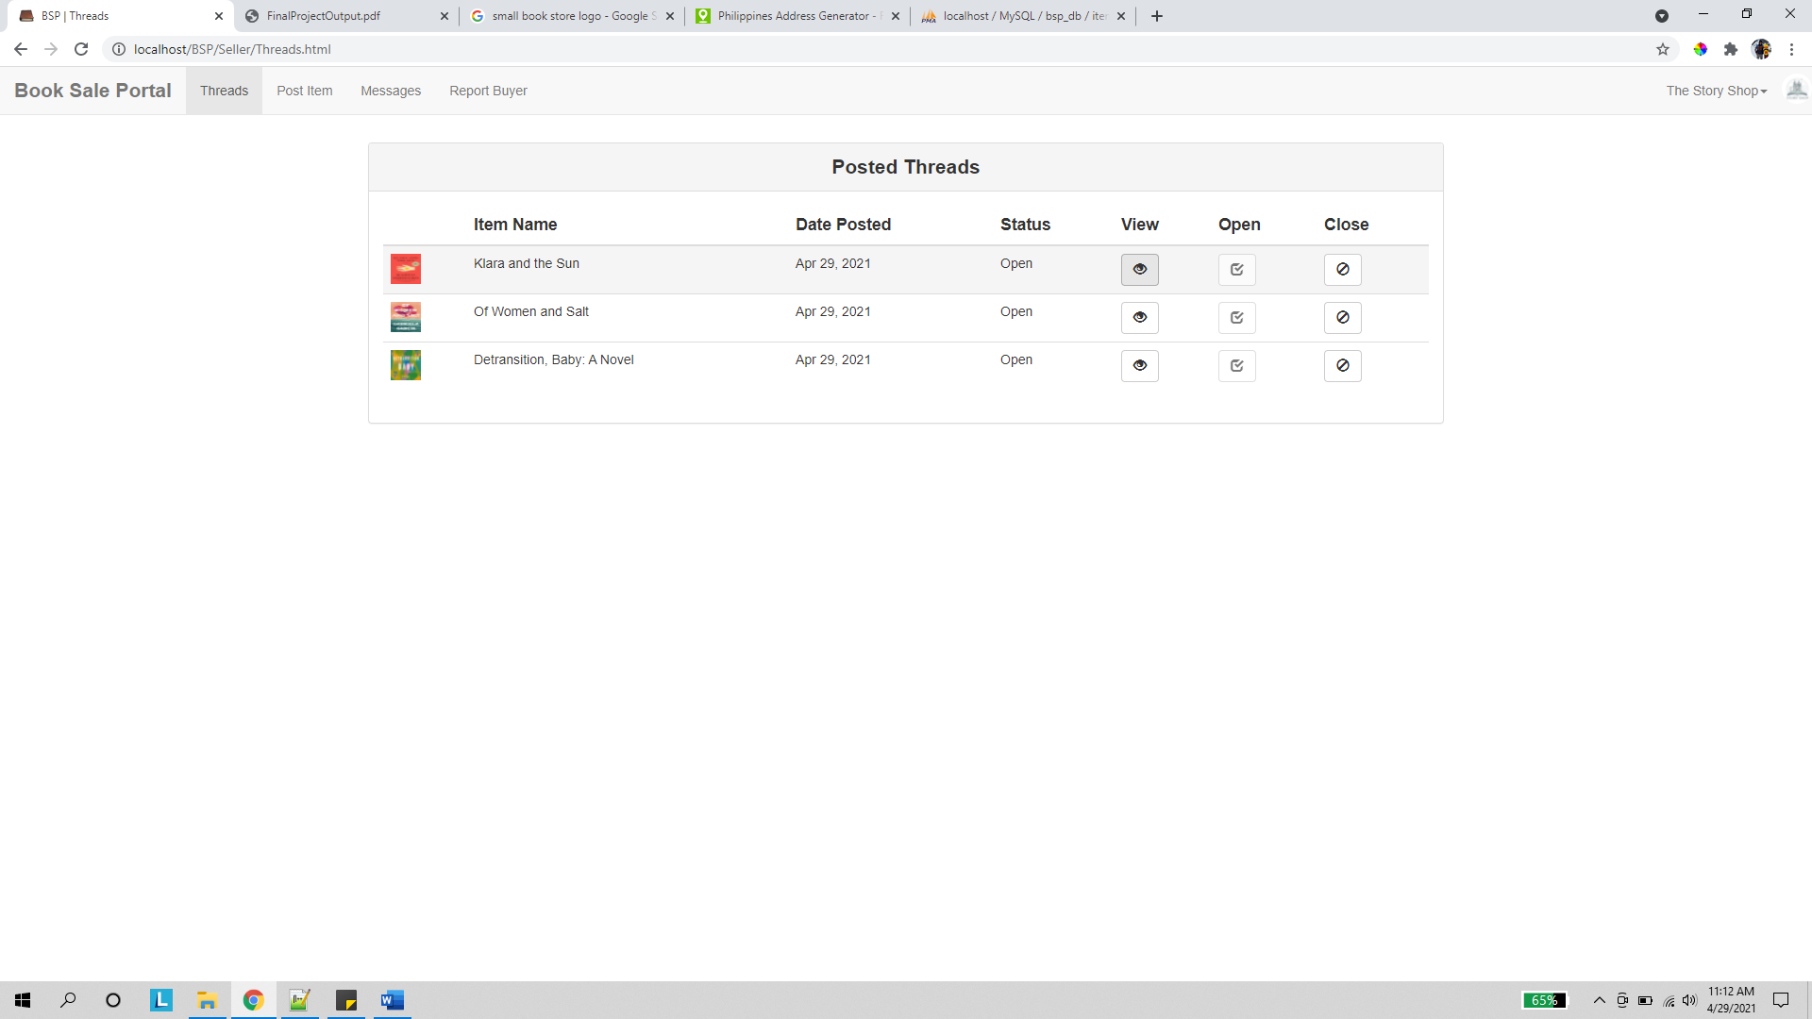

Upon clicking the view button, the user is redirected to the succeeding page.

View Thread

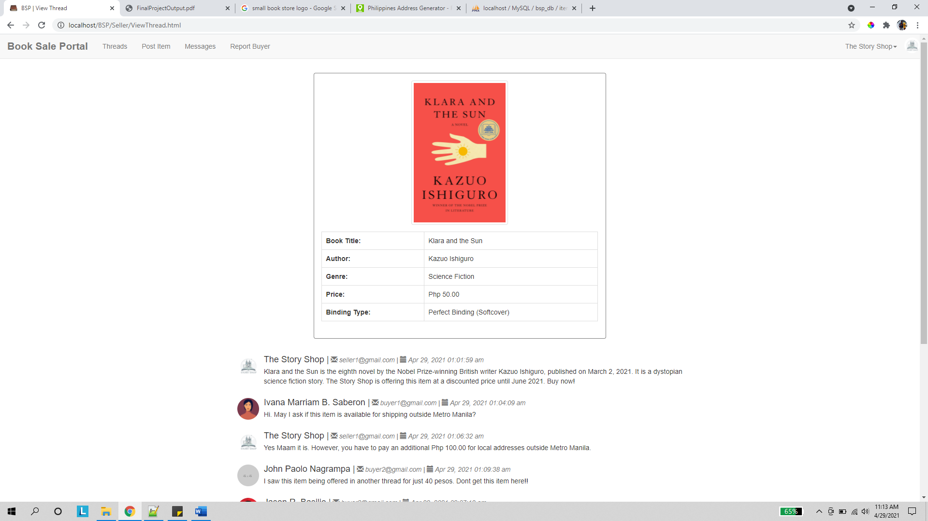

In the view thread page, the company can see the info of the item it posted along with comments made by buyers.

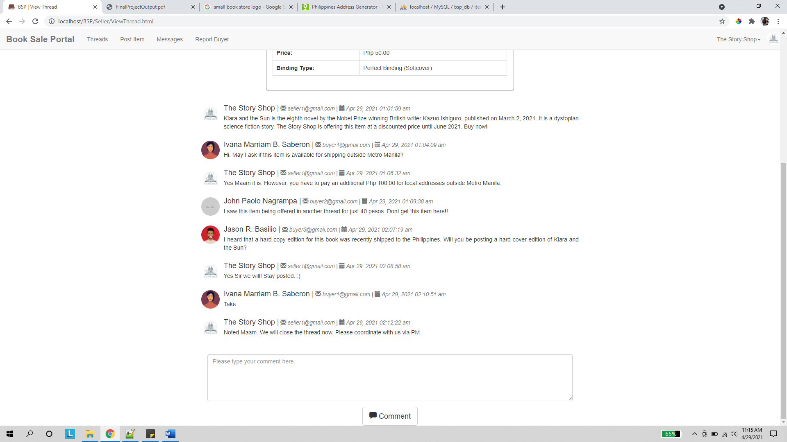

The company can add its own comments to the thread in reply to buyer inquiries or to provide additional info about the item they are offering.

Post Item

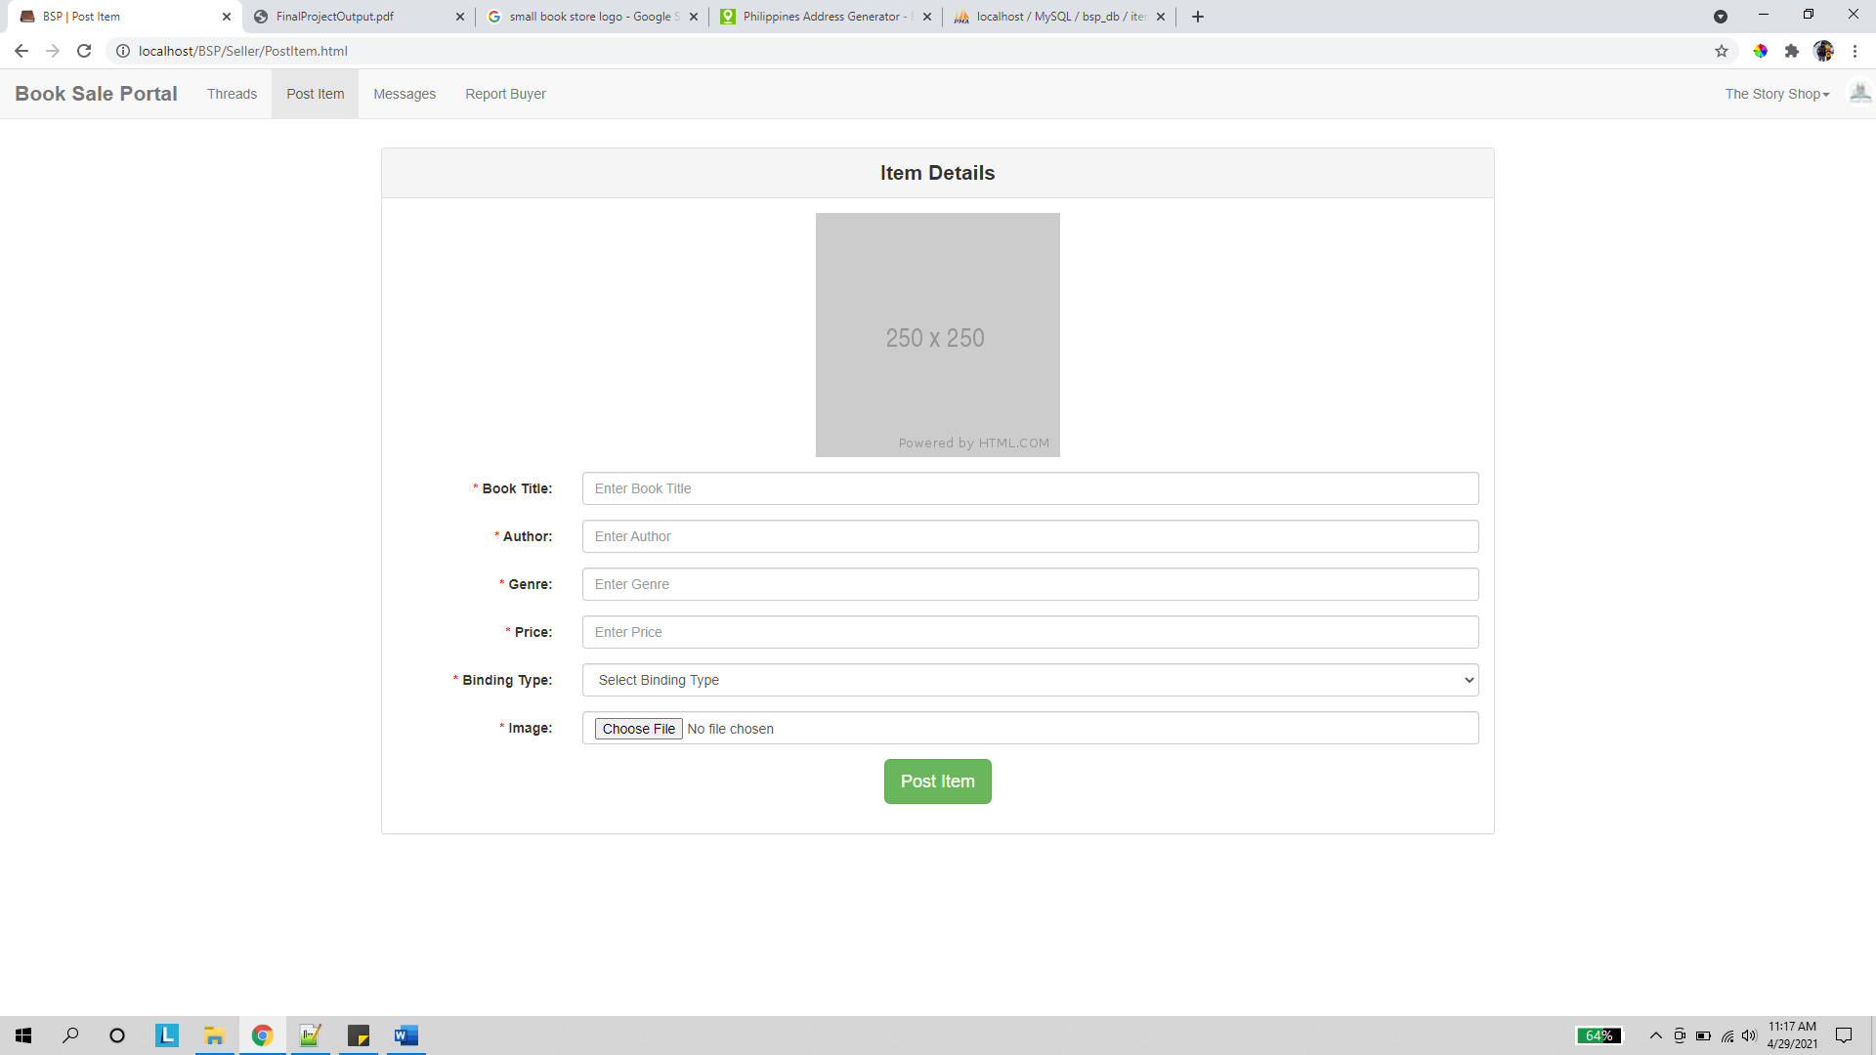

The company can post a new item via this page. Once posted, a thread for that item will automatically be created.

Messages

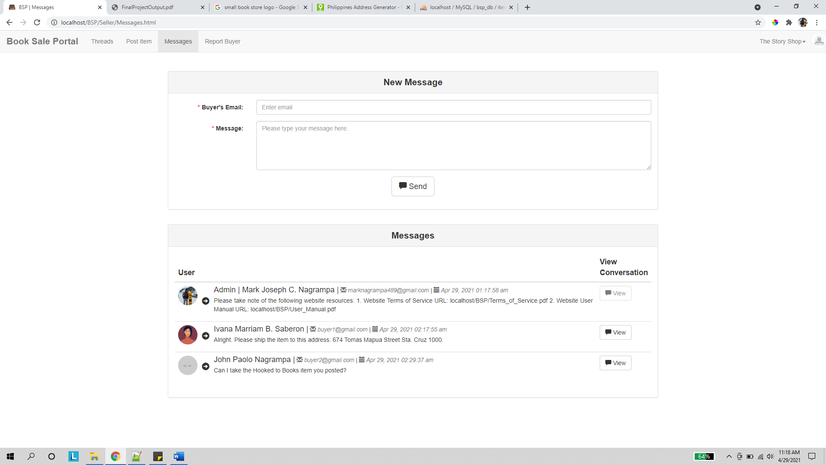

In the messages page, the seller can create a new message to a buyer by providing that buyer account’s email.

The user can also view a list of prior PMs conversed with buyers as well as the admin’s announcement message. Note that the PMs displayed in this page correspond to the last message sent between the seller and buyer account.

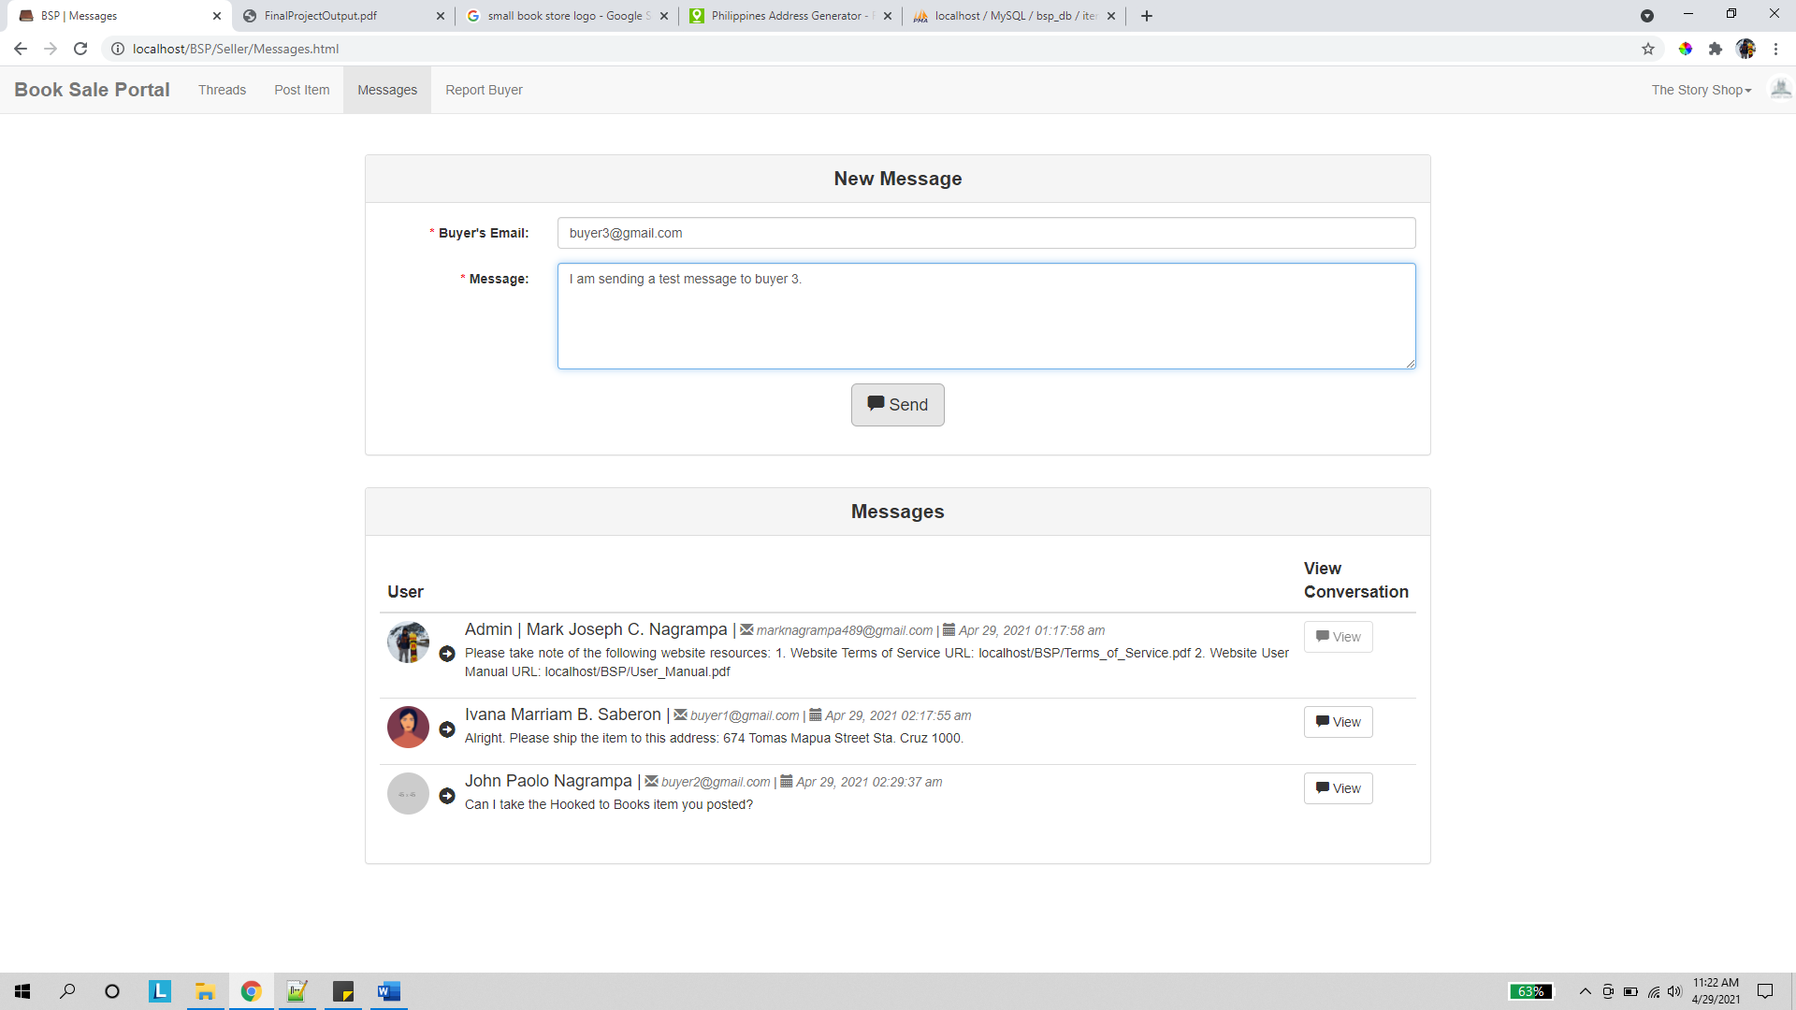

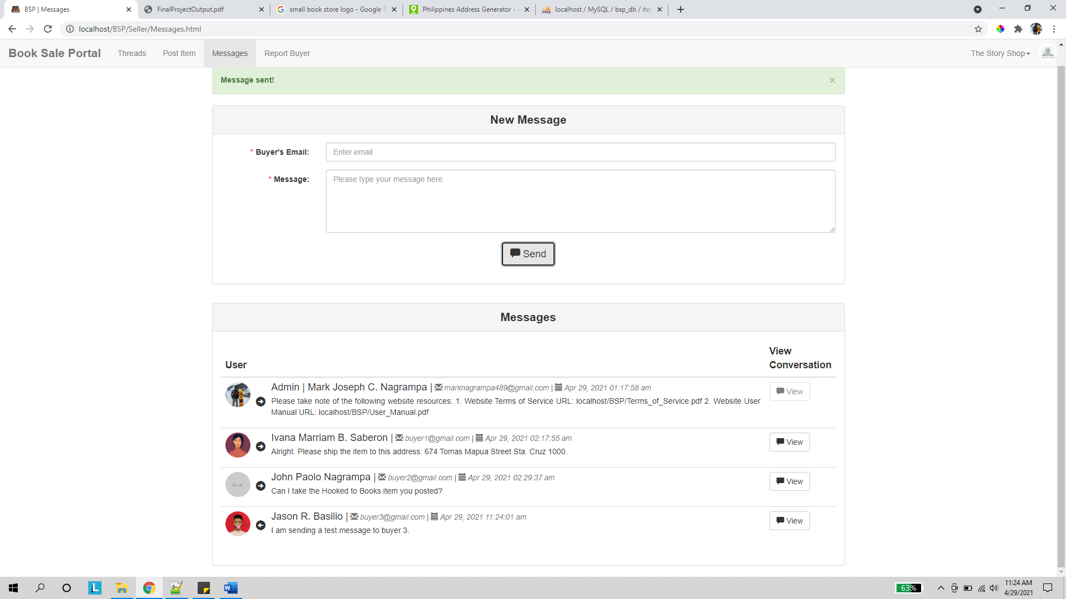

Upon sending a message to an unacquainted buyer, a new row is added into the messages list.

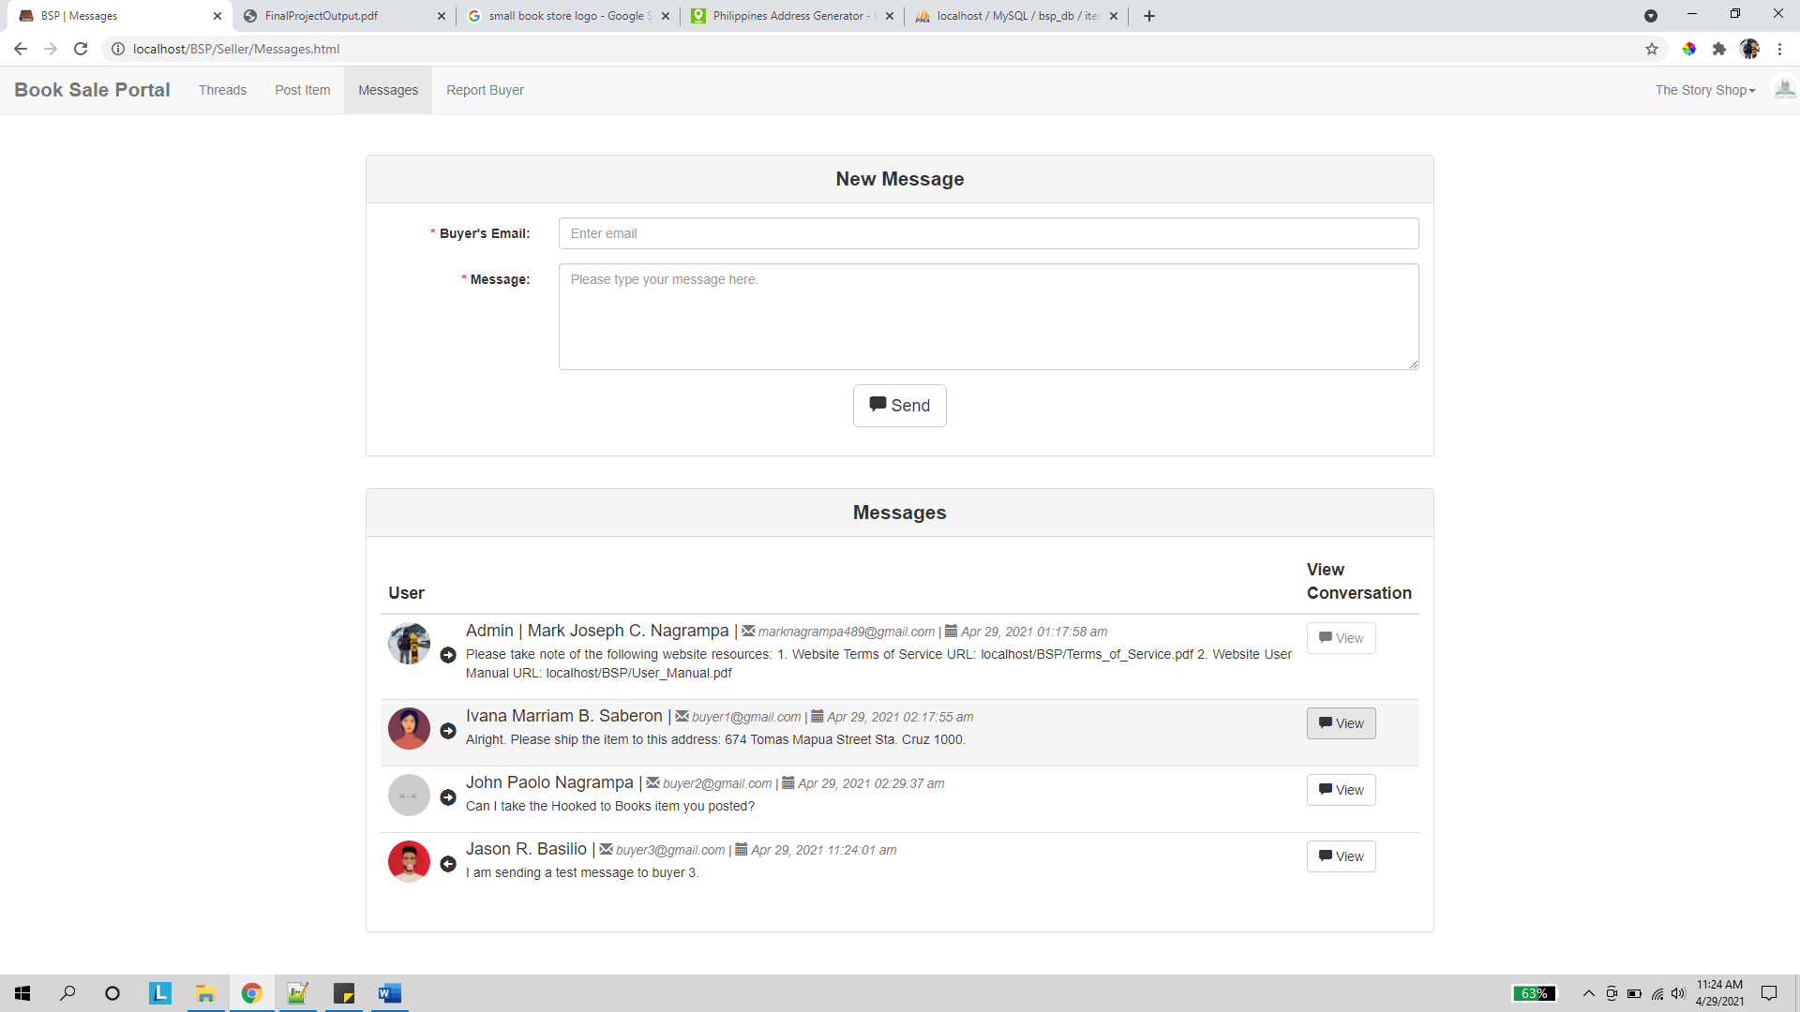

Clicking the view conversation button on any of the messages directs the user to the succeeding page.

View Message

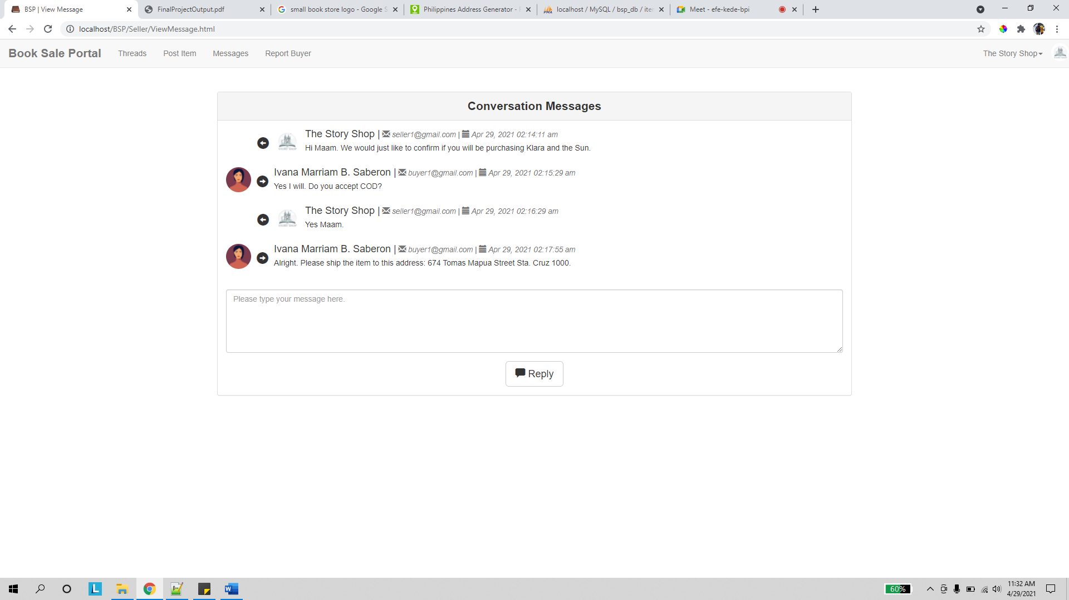

The user can then see the entire conversation made with the buyer in the view message page.

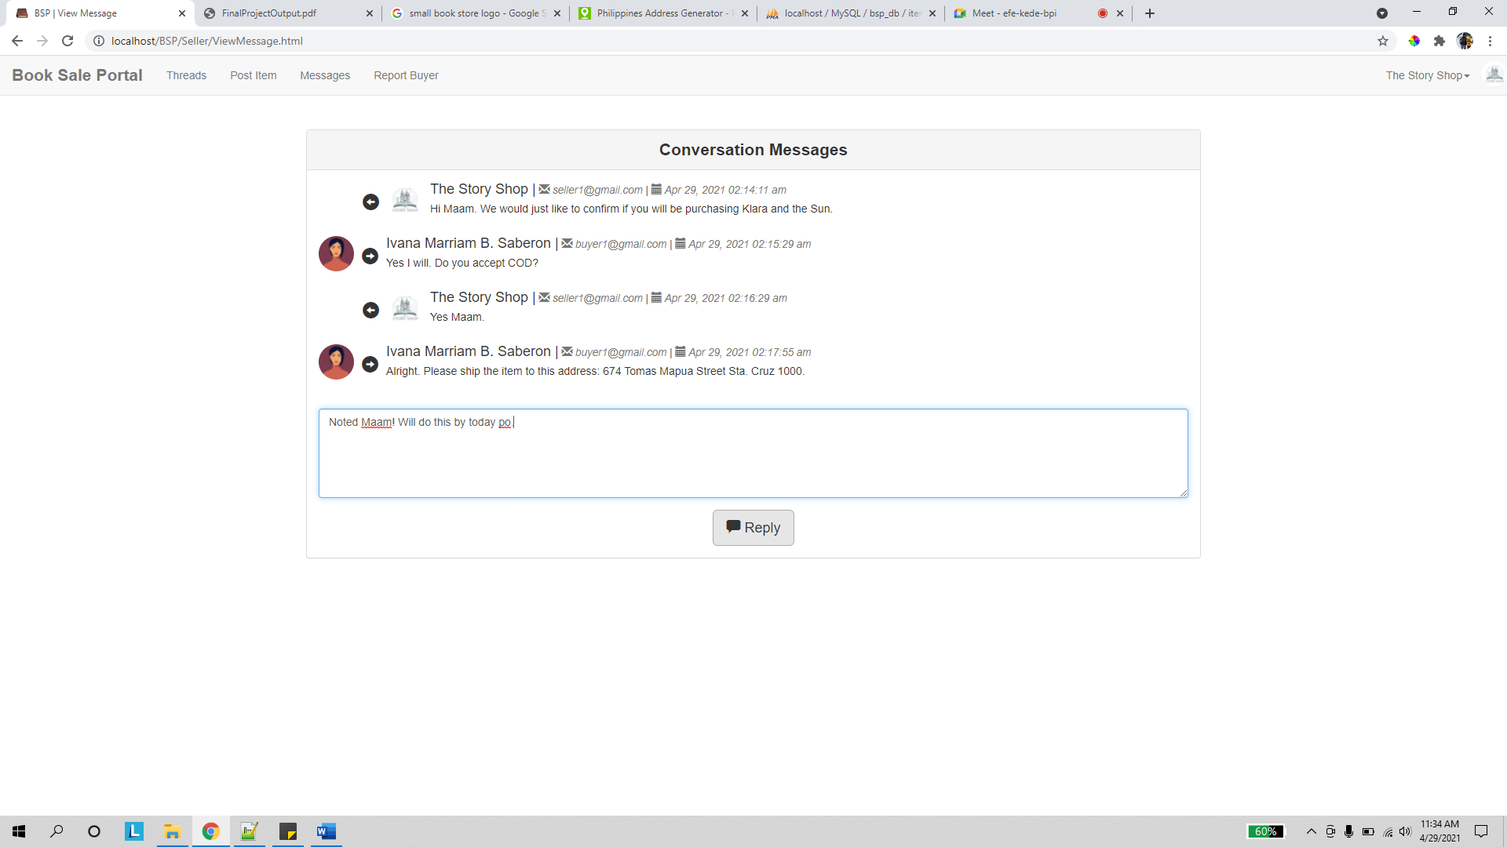

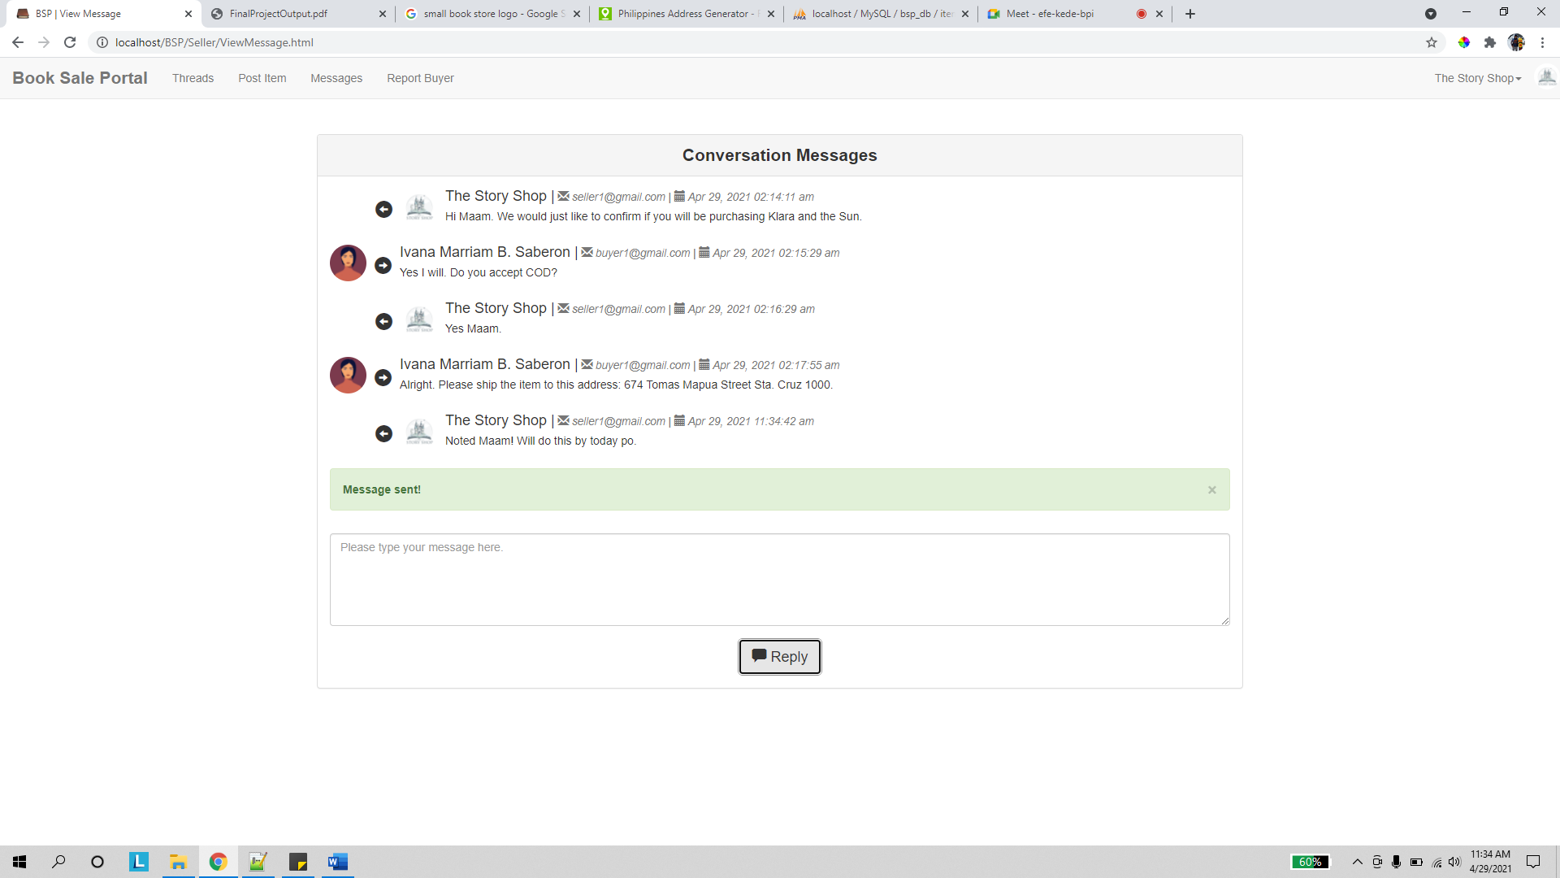

Upon sending a reply, the new message is added into the conversation panel.

Report Buyer

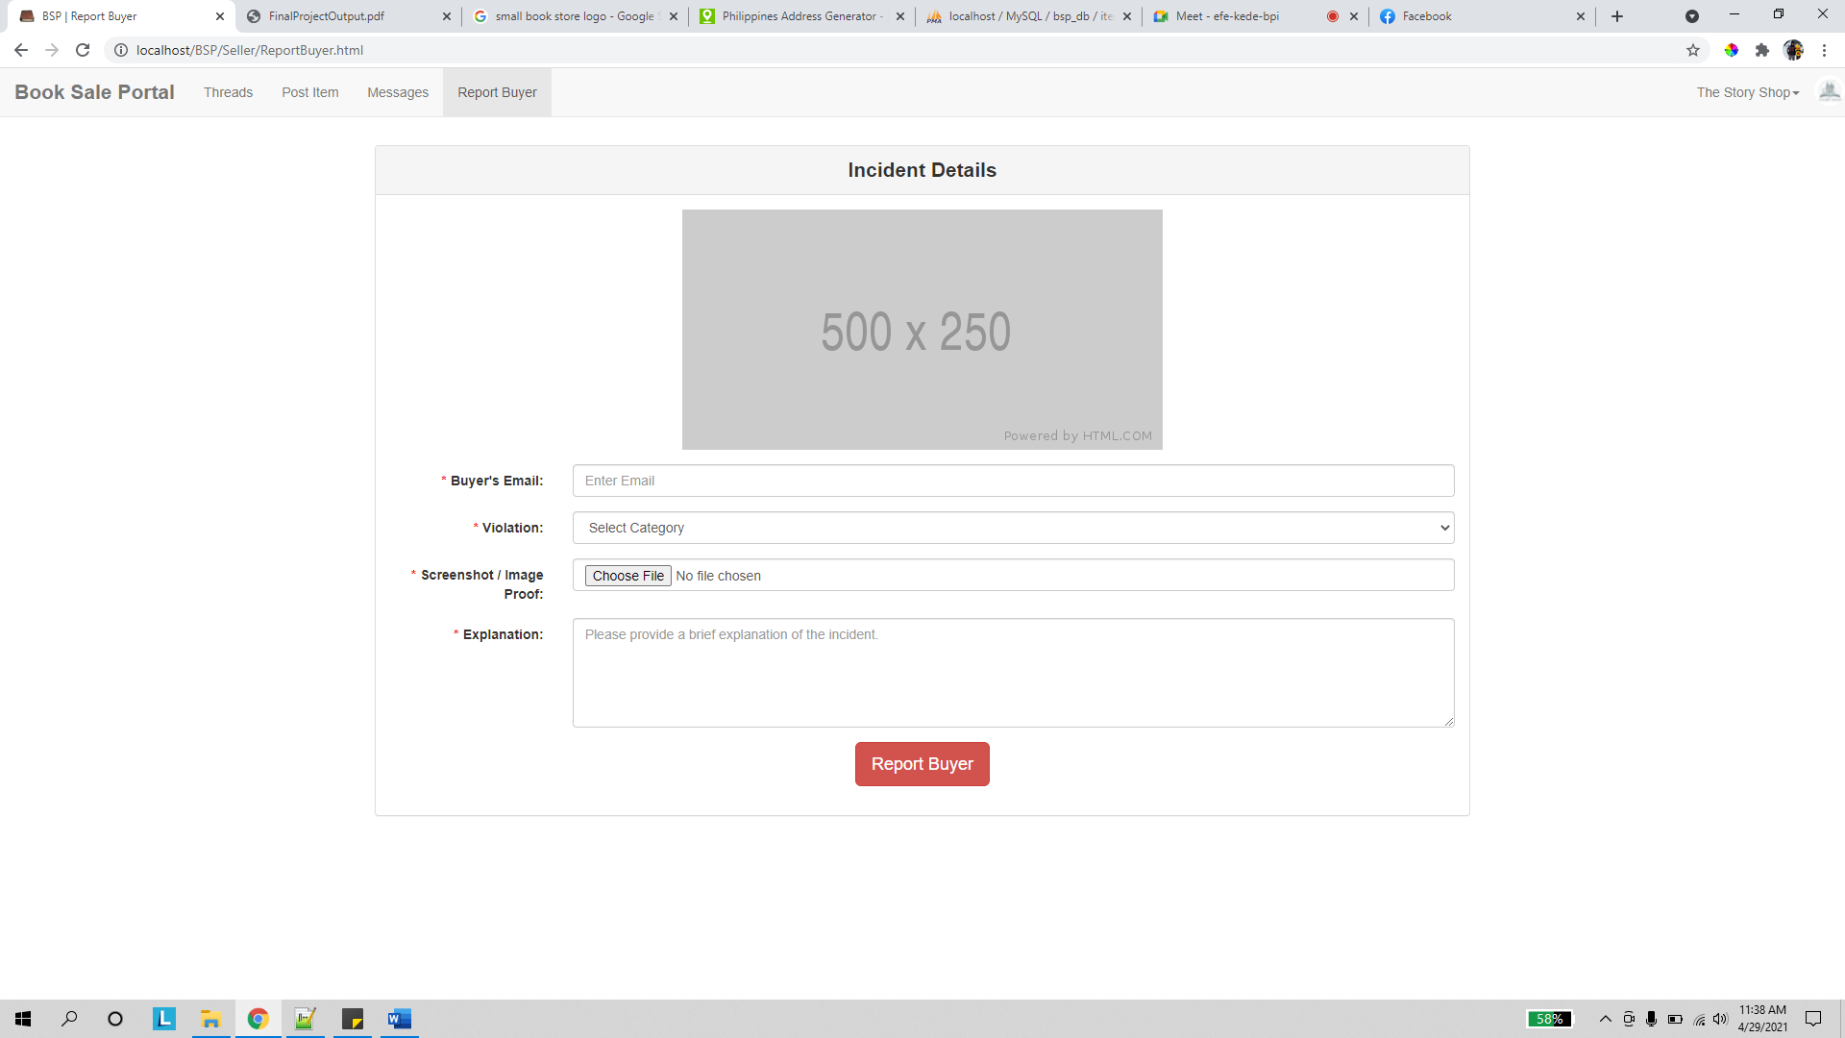

In the report buyer page, the seller can file a complaint against a buyer who violates the website’s terms of service.

1. **Buyer Pages**

Profile

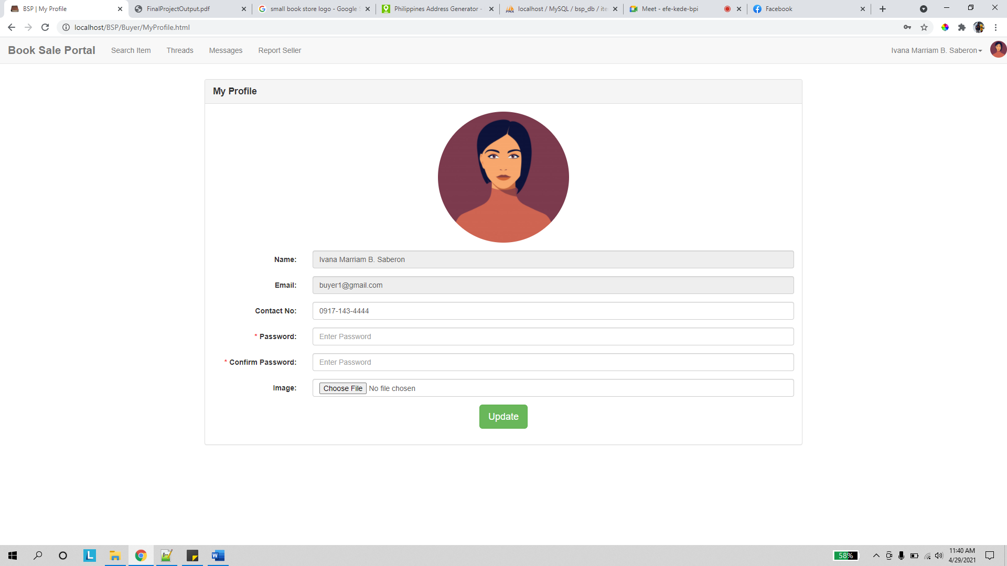

Similar to the 2 previous profile pages, the buyer can modify his/her account details via this page.

Search Item

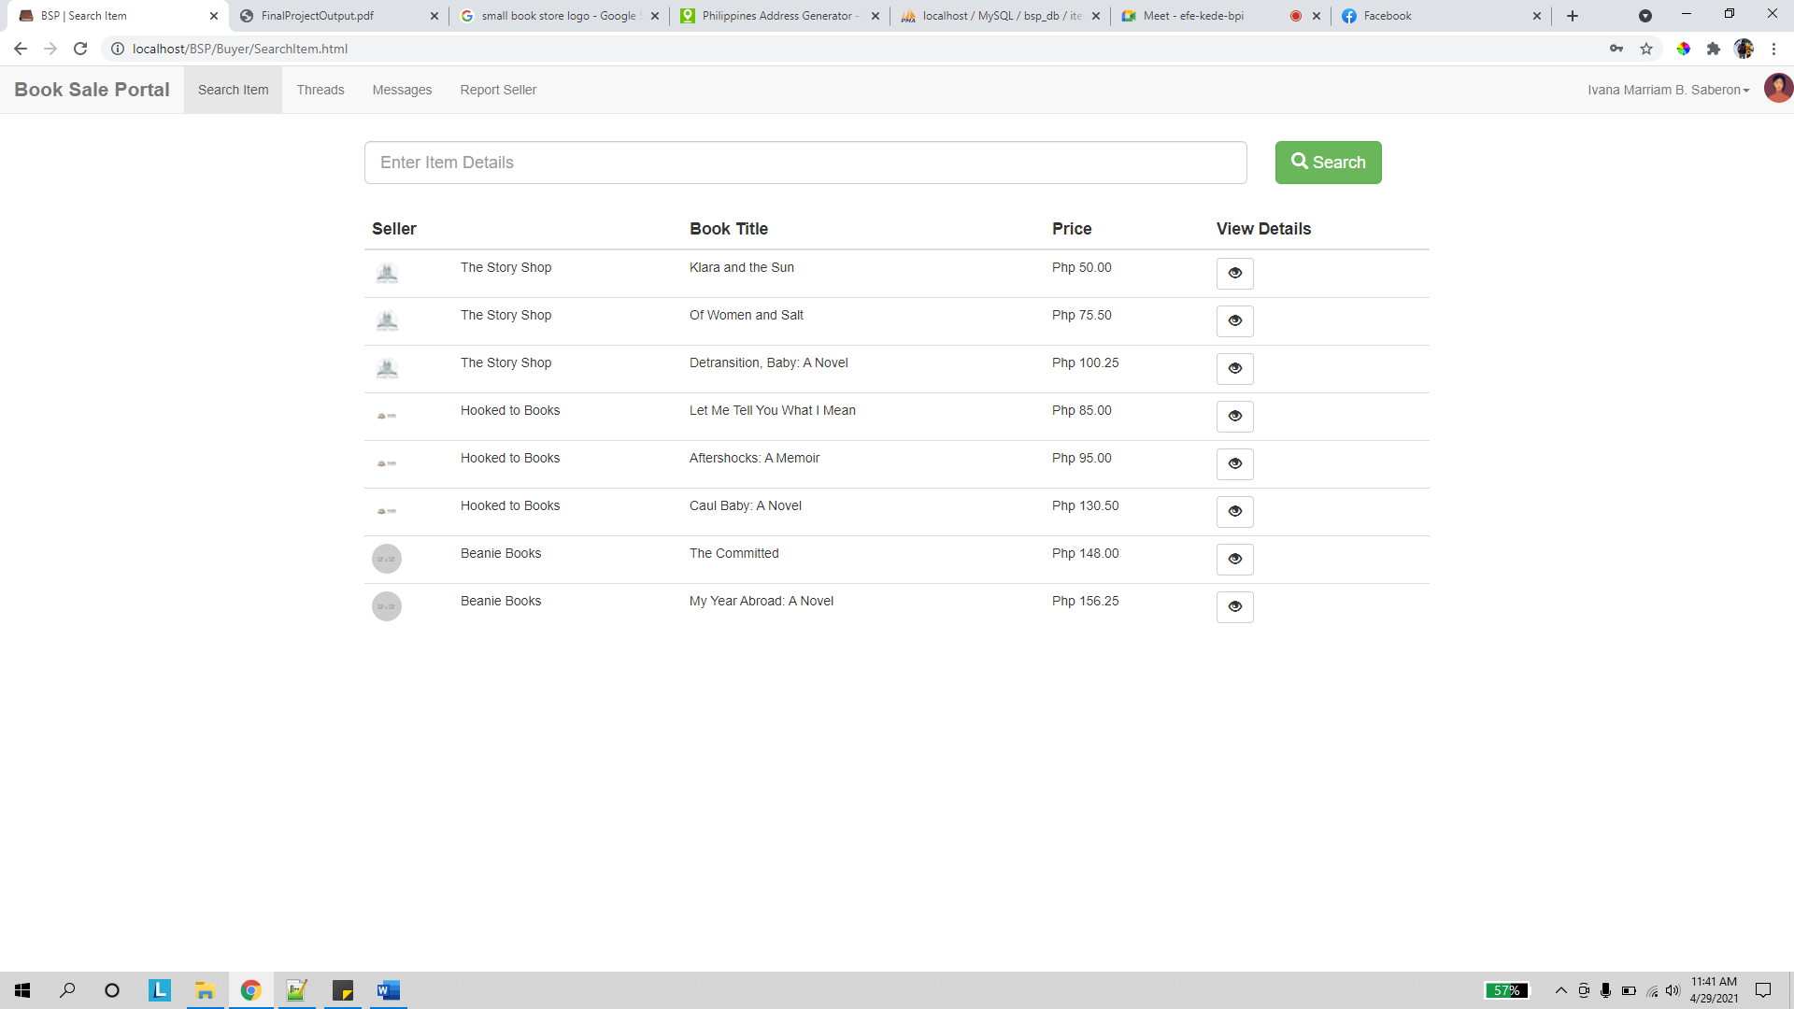

In the search item page, the buyer can view a list of all available products.

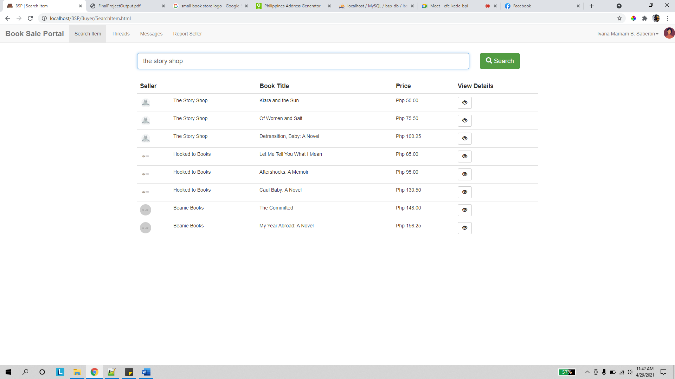

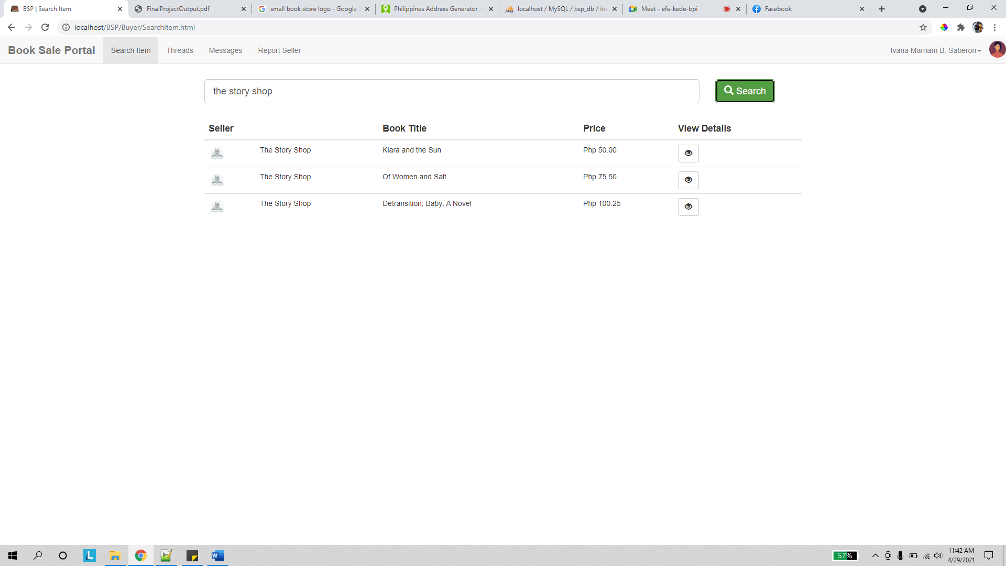

He can filter the list via the seller, book title, author, and genre categories as seen in the image above.

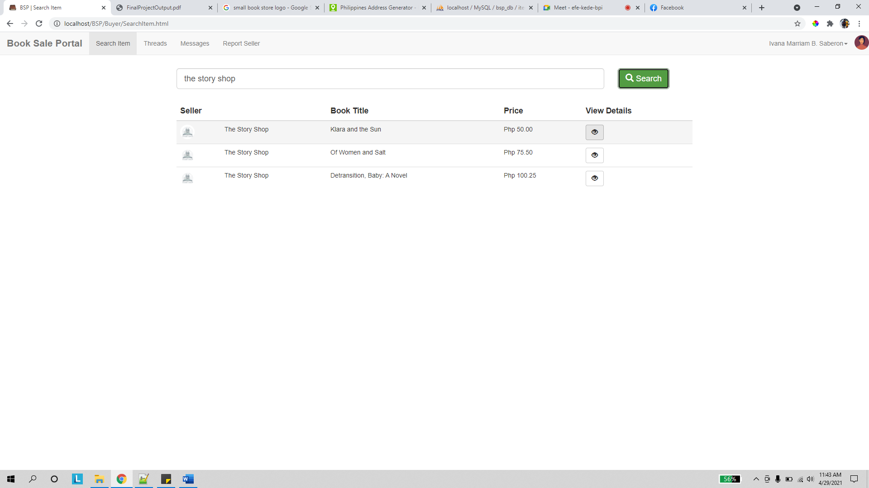

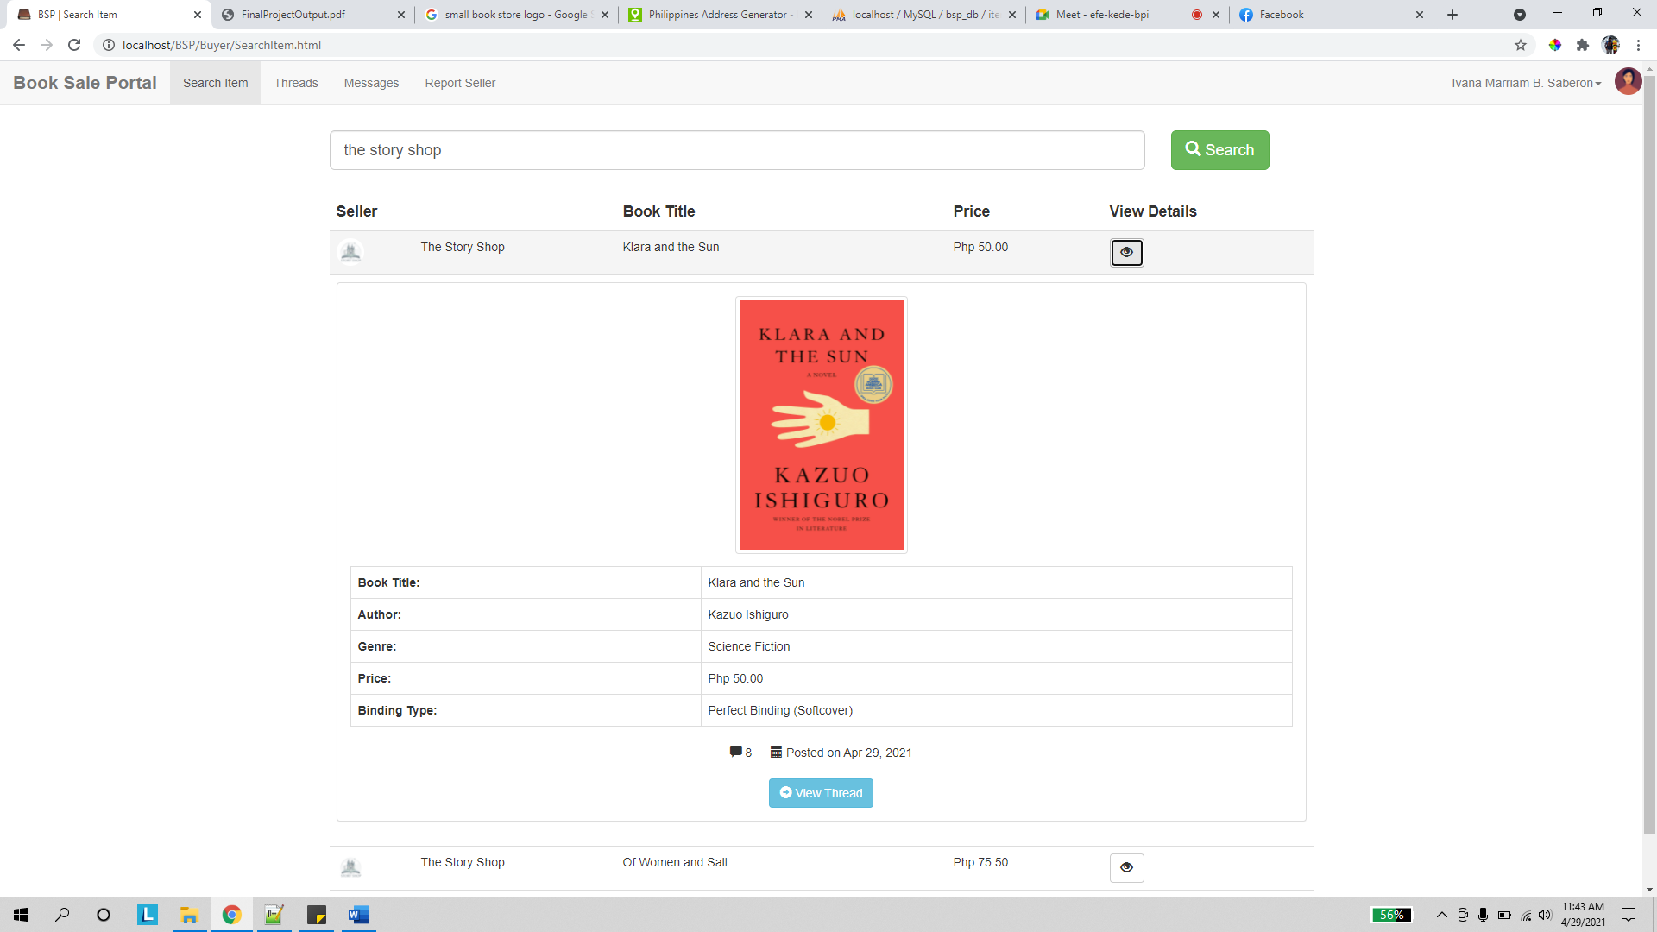

Clicking on an item’s view details button expands a panel which shows that item’s info. Aside from this, the buyer can see the number of comments and the date when the item was posted.

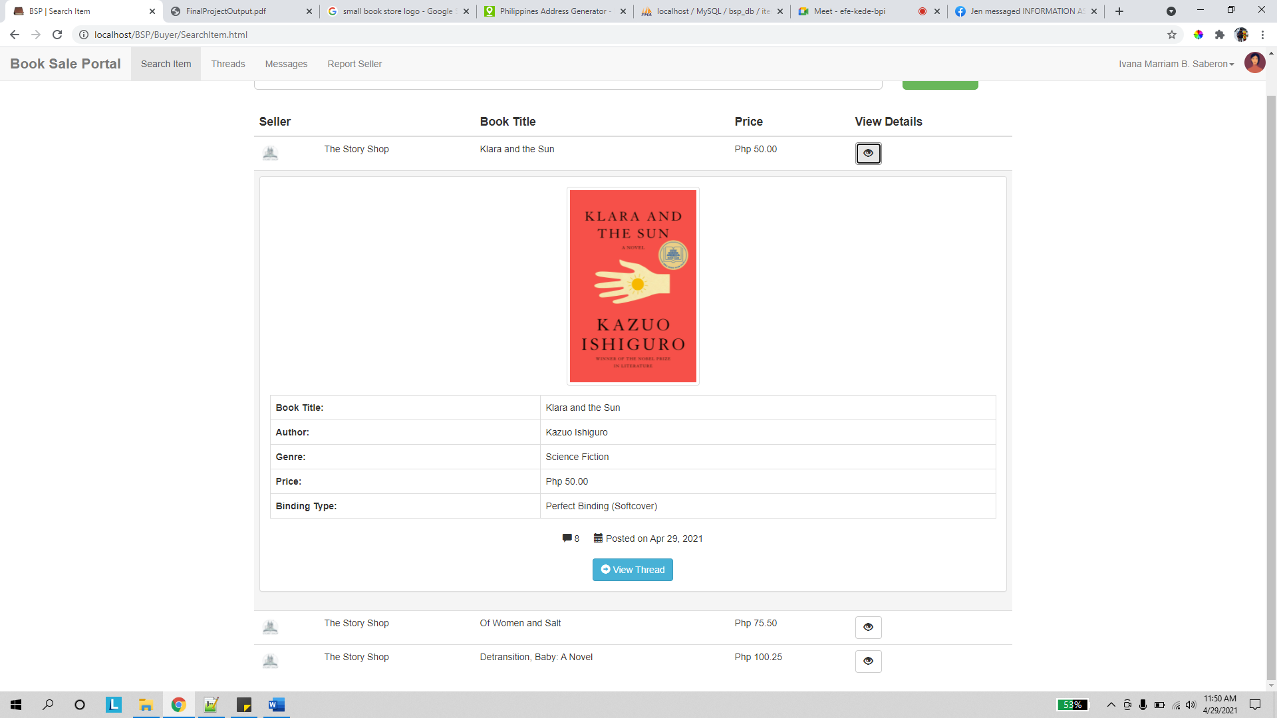

Clicking on the view thread button redirects the user to the succeeding page.

View Thread

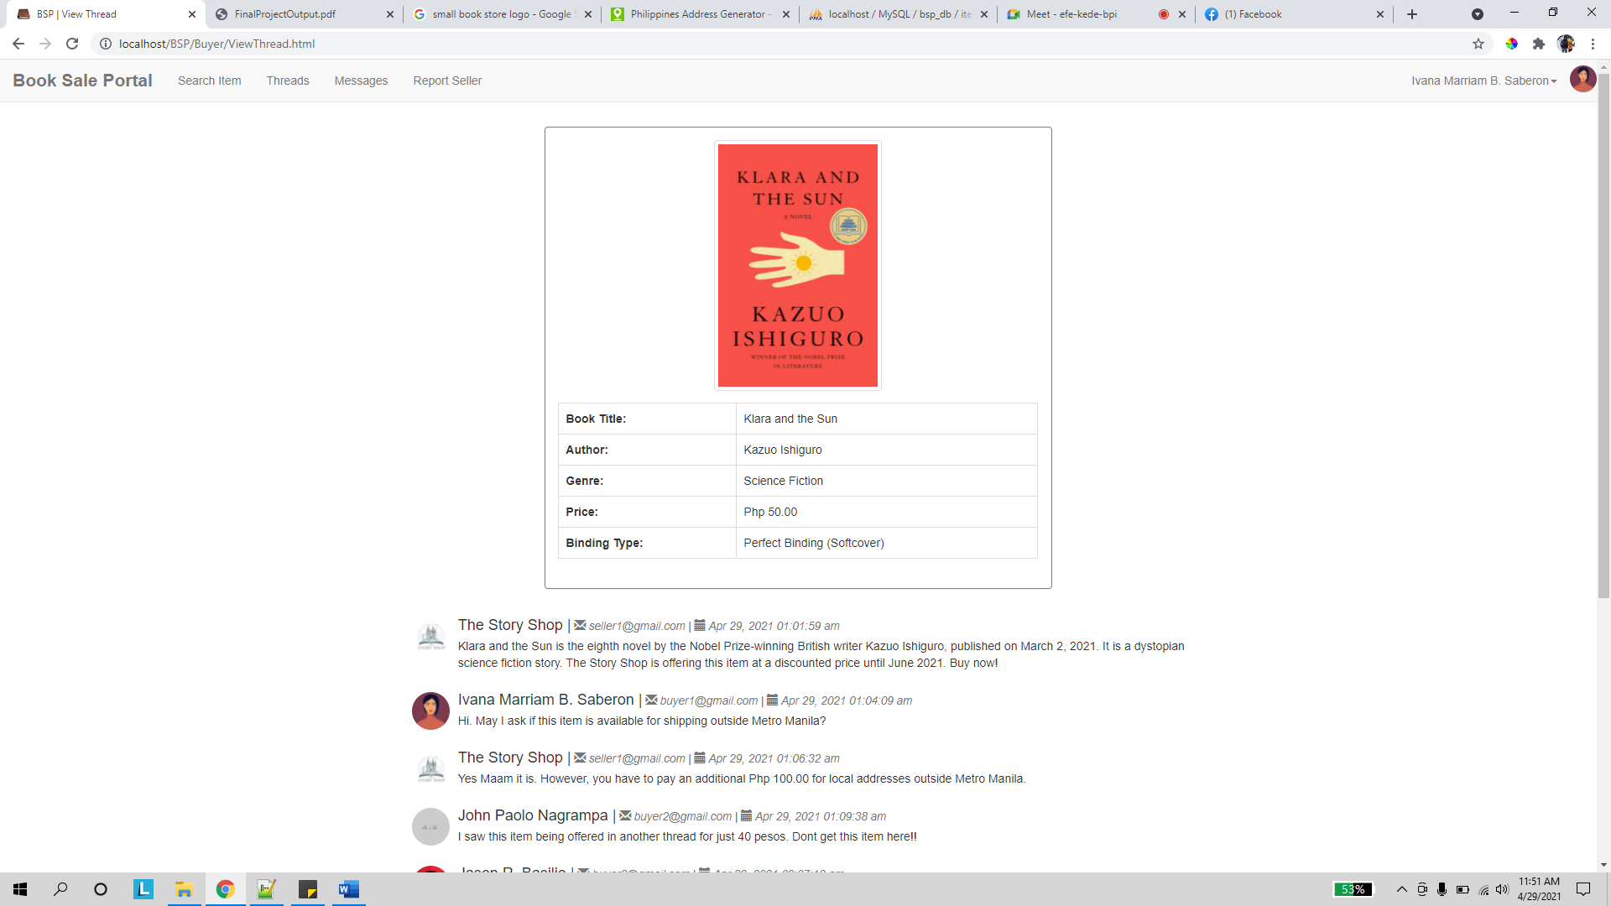

Similar page with previous section. See seller’s view thread page description.

Threads

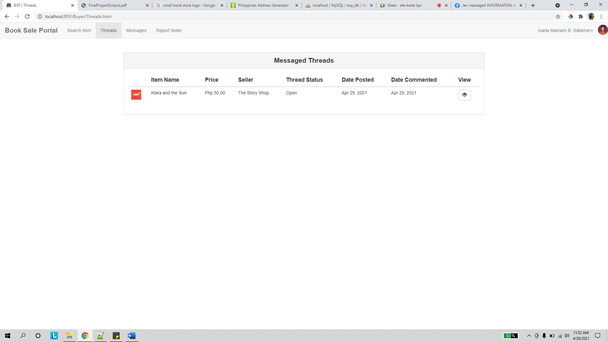

In the threads page, the buyer can see a list of threads he/she commented on. Clicking on the view button of any record redirects the user to the previous page.

Messages

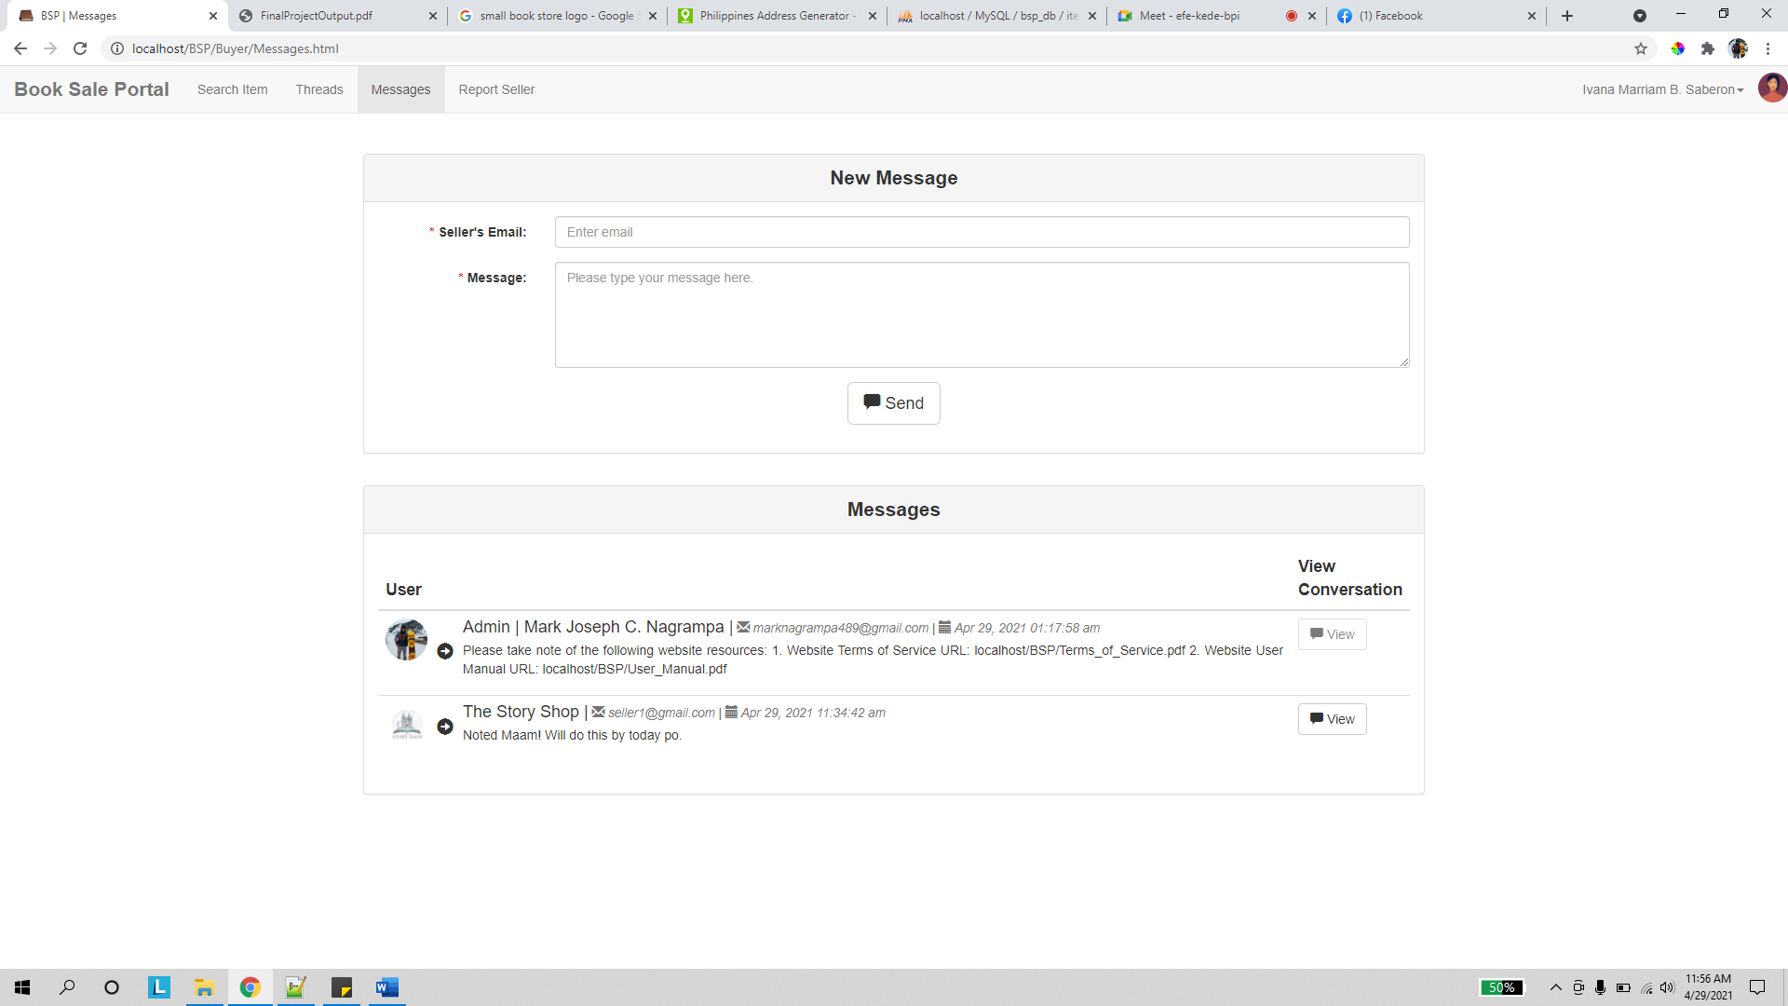

Similar with page from previous section. Please see seller’s messages page.

View Message

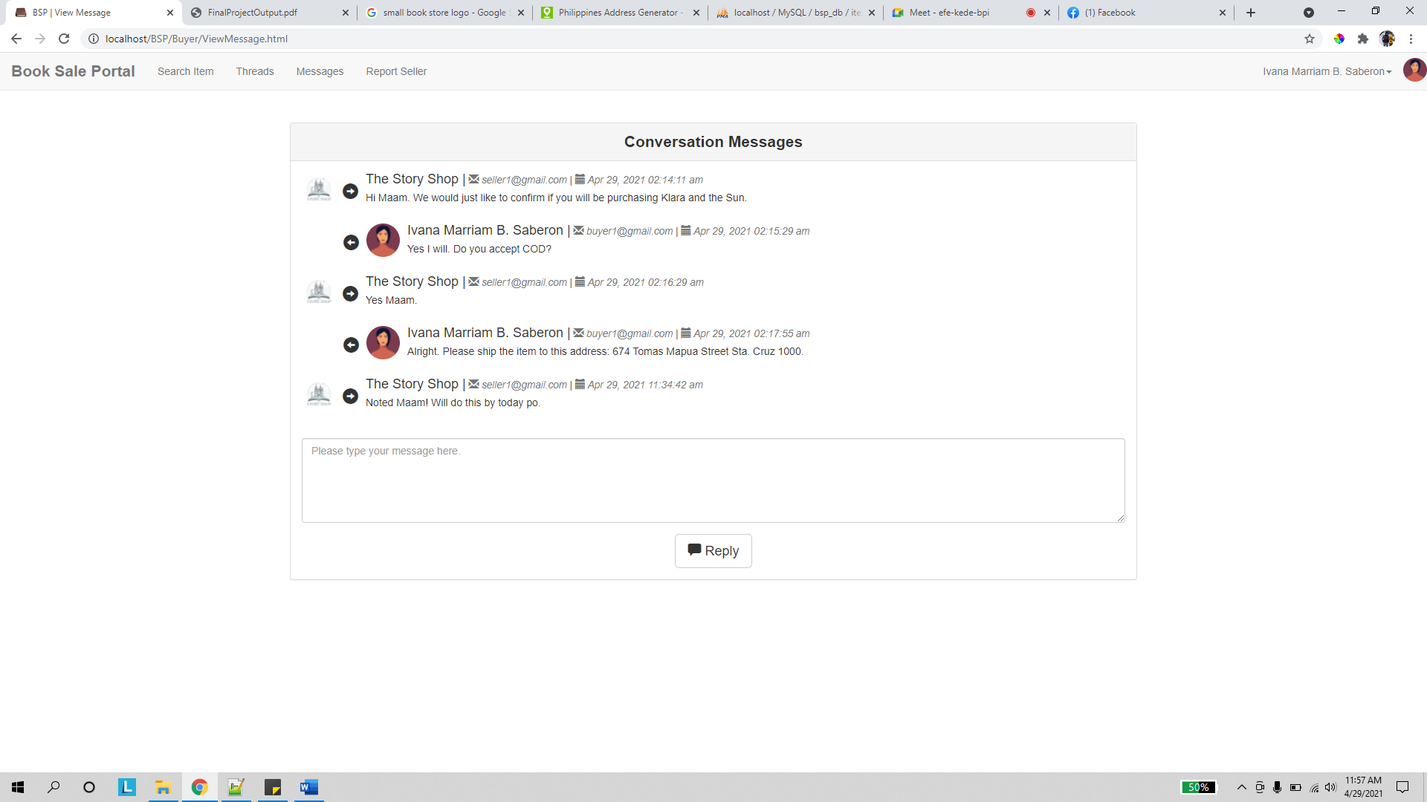

Similar with page from previous section. Please see seller’s view message page.

Report Seller

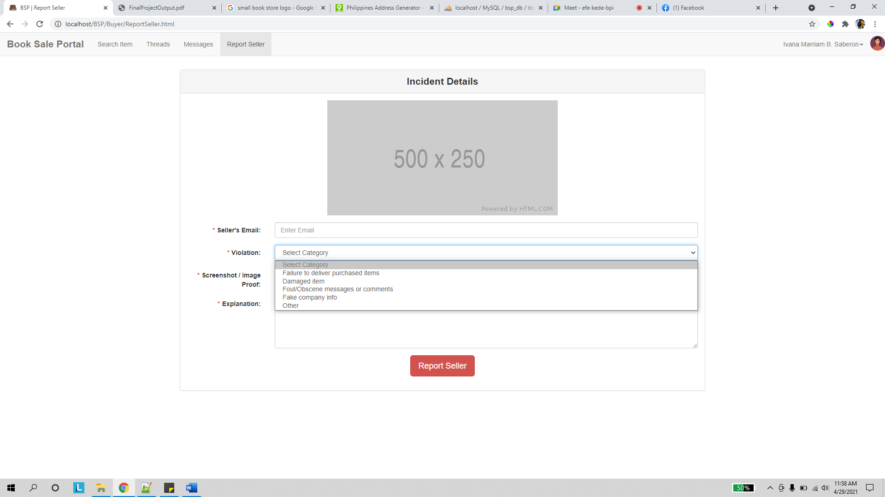

Similar with report buyer page from seller’s section. The only notable difference is the violation categories listed.

# User functionality

1. **Admin**
   1. **Verifying Pending Company Accounts**

See previous section: Admin-> Companies for Verification page description.

* 1. **Posting Announcements**

See previous section: Admin-> Post Announcement page description.

* 1. **Activating / Deactivating User Accounts**

See previous section: Admin-> Accounts page description.

* 1. **Reviewing Filed Complaints**

See previous section: Admin-> Accounts

and Admin-> View Complaint page descriptions.

* 1. **Creating & Restoring DB Backups**

This platform uses MySQL as its database management system. The resource below illustrates how to perform backups and restorations using this database management system:

* + Database Records:

<https://mediatemple.net/community/products/dv/204403864/export-and-import-mysql-databases>

* + Image Resources:

The platform’s image resources are saved outside the main DB. To backup image resources, simply locate the website’s img folder and copy/download the file. To restore these image resources, simply upload the backup img folder back onto the server.

Please note: When performing backups / restorations, you must perform both the Database Records and Image Resources steps.

1. **Seller**
   1. **Posting new items**

See previous section: Seller-> Post Item page description.

* 1. **Managing and Viewing Your item thread posts.**

See previous section: Seller-> Threads

and Seller-> View Thread page descriptions.

* 1. **Marking Items as Bought**

To mark an item as bought simply close the thread for that item. Note that it is generally good practice to tell the buyer to comment “Take” on the item thread or leave a comment indicating the name of that user to inform other buyers regarding the reason for the thread’s closure.

Once closed, the item thread will be permanently deleted within 7 days unless it is marked reopened anytime during this period.

* 1. **Messaging Buyers**

See previous section: Seller-> Messages

and Seller-> View Message page descriptions.

* 1. **Reporting Buyers Violations**

See previous section: Seller-> Report Buyer page description.

Also note that it is a good practice to follow the report image submission formats for each violation type below in order for your report to be processed by the administrator easier.

1. Failure to Pay

Post a screenshot of your message history with the buyer which includes sections wherein the buyer continuously ignores your attempts to settle payment details with them.

1. Foul/Obscene messages or comments

Post a screenshot of the vulgar message/comment.

1. Spamming

Post a screenshot of your message/thread page wherein the buyer has flooded the display with irrelevant spam content.

1. Promoting Content of Competitors

Post a screenshot of your thread page wherein the buyer explicitly commented an offered item of a competitor or defamed your thread because of the existence of such a thread.

1. Other

For other complaint types, please include a screenshot of a relevant platform web page with the image you wish to upload.

State incident explanations in clear English and keep explanations concise if possible.

1. **Buyer**
   1. **Searching for items**

See previous section: Buyer-> Search Item page description.

* 1. **Viewing and Commenting on Threads**

See previous section: Buyer-> Search Item, Buyer-> Threads

and Buyer-> View Thread page descriptions.

* 1. **Messaging Sellers**

See previous section: Buyer-> Messages

and Buyer-> View Message page descriptions.

* 1. **Reporting Seller Violations**

See previous section: Buyer-> Report Seller page description.

Also note that it is a good practice to follow the report image submission formats for each violation type below in order for your report to be processed by the administrator easier.

1. Failure to deliver purchased items

Post a screenshot of your message history with the seller which includes sections wherein the seller continuously ignores your attempts to settle delivery details of a purchased item with them.

1. Damaged Item

Post a screenshot of your message history with the seller which includes sections wherein the seller continuously ignores your attempts inquiring regarding the status of a damaged item together with the image of the item delivered to you.

1. Foul/Obscene messages or comments

Post a screenshot of the vulgar message/comment.

1. Other

For other complaint types, please include a screenshot of a relevant platform web page with the image you wish to upload.

State incident explanations in clear English and keep explanations concise if possible.

# User agreement

1. **Terms and Conditions – Seller**

This website will store information about your company such as its name, address, email, and its contact number. Aside from this, the website will also store a chosen employee’s (the point person’s) personal info; these information are the selected employee’s name and contact number.

This website will also store information about all items your company wishes to sell via the platform such as its book title, author, genre, binding type, price, and image.

By using the website, your company agrees for its forum posts and messages to be monitored by the platform administrator. Although the administrator does not have unlimited access to these records, screenshots in reports made by complaining buyers will include the private information stated above.

Violations such as failure to deliver sold items, delivering defective/damaged items, use of foul or obscene language in messages or thread comments, and supplying bogus company information are offenses which are subject to account deactivation/registration denial if proven true.

1. **Terms and Conditions – Buyers**

This website will store your name and email address.

By using this platform, you agree for your forum comments and messages to be monitored by the platform administrator. Although the administrator does not have unlimited access to these records, screenshots in reports made by complaining sellers will include the private information stated above.

Violations such as failure to pay for purchased item, use of foul or obscene language, promoting content of a seller’s competitors in their thread posts, and forum/message spamming are offenses which are subject to account deactivation if proven true.

# Maintenance

1. **Automated Tasks**
2. **Automated Deletion of Threads**

The platform will automatically delete threads which have been closed for over a week (7 days and older).

1. **Displaying Random Items for Sale in the System’s Homepage**

The platform will automatically select up to (5) random items for sale in the system’s home page. Seller’s company names are obscured in this showcase display in order to prevent providing unfair advantages to selected companies.

1. **Manual Tasks**
2. **Seller Verification**

Verification of pending seller accounts and performing due diligence would be done manually by the administrator in charge.

1. **Closing Reported Accounts**

Closing reported accounts would be done manually by the administrator in charge. With this in mind, it is the administrator’s responsibility to continuously check the reports being filed against the platform’s buyer and seller accounts.

1. **Database Backups**

No explicit schedule is set for backing up database records. However, the developer highly recommends the administrator to perform a monthly database backup. Please refer to User Functionality -> Admin -> Creating & Restoring DB Backups